FRED-MaarjAM friendship

LINKS!
Folder with data files

Zotero Folder : https://www.zotero.org/groups/5922598/fred-amf_2025

Table of Contents:
FRED-MaarjAM friendship 1
Running Meeting Notes 2
September 17th, 2025 2
June 11th, 2025 2
May 7th, 2025 3
April 9th, 2025 5
General Notes 5
Science questions (Needed to evaluate is it possible/worth it!) 7
Next steps: ACTION ITEMS 8
STARTING QUESTIONS TO GUIDE ANALYSES 9
First exploratory analyses in Ecobank (reduced MaarjAM) and FRED (Tanel) 06/05/25 12
MaarjAM and FRED - presence/absence based exploratory analyses 18
Plant genus level exploratory analyses 09.06.25 22
Summary Table of Current Results 06/11/2025 28

____________________________________________________________________________

Running Meeting Notes

January 13, 2026

Attendees: Ben Sikes, Tanel Vahter, Joe Edwards, Luke McCormack, Jorrit Poelen, Teddy Nikitin

Tanel needs to step back from analysis lead. How do we move forward with stops and starts, responsibilities, and find a way to move forward.

Ways to help move forward -
- Github repository for baseline
- Regular meetings
- An example of stop-and-go distributed communities -
  - “Relations Ontology”
  - https://github.com/oborel/obo-relations
  - https://github.com/oborel/obo-relations/issues/325 (tasks started in 2019!)
  - Moving forward slowly aided by monthly meetings that I can join when possible or when the topic comes up again.

Individually and collectively go through results so far in detail.
- Some appear dependent on the data we use – does that mean they are/aren’t robust?
- What are the key aspects that we need to tackle? For example, what level of organization (e.g. genus) for which analyses?
- How can we identify tasks, grounded in questions and data, that allow us to distribute work?

Jorrit - FRED 4.0? Would you like GloBI to index FRED 4.0? If so, please let me know how to best access the data files associated. https://globalbioticinteractions.org/microbenetnet#dataset-review contains more and more microbenetnet related datasets - this is geared towards facilitating access to the “raw” data as to allow researchers easier access to play around with the data.

Luke - reference to previously ecological questions / expected answers https://docs.google.com/document/d/1NIx1X24DW-z5e-MzNbNOccld1OTqO-ojYfwnDfw6lQA/edit?tab=t.0#bookmark=id.rzjpjgqt1bw9 . Which datasets do we feel comfortable using to answer these questions?

Tanel - Internal use MaarJAM version contains community data (sets of AM fungi found with a plant, for example with community sequencing), whereas public version “only” contains associations data (plant - fungi associations) on occurrence level (single AM fungus). This could have, for example, come from Sanger sequencing and is out of the AMF community context. Both have geospatial-temporal information along with the associated study.

Joe is asking what dataset would provide colonization . Luke says that FRED contains this as a root trait.

Re: FungalRoot database
- Ben shared a reference to the FungalRoot dataset https://scholar.google.com/scholar?output=instlink&q=info:TqHfzg8n3x0J:scholar.google.com/&hl=en&as_sdt=0,5&scillfp=7416977455378605848&oi=lle
- Tanel also shared - Soudzilovskaia, N.A., Vaessen, S., Barcelo, M., He, J., Rahimlou, S., Abarenkov, K., Brundrett, M.C., Gomes, S.I.F., Merckx, V. and Tedersoo, L. (2020), FungalRoot: global online database of plant mycorrhizal associations. New Phytol, 227: 955-966. https://doi.org/10.1111/nph.16569
- Associated GloBI issue https://github.com/globalbioticinteractions/globalbioticinteractions/issues/1105 (not yet indexed)
- about the fungal root data access - very scant information, namely "Data availability FungalRoot v.2.0 is available from the PlutoF (https://plutof.ut.ee) and GBIF (https://www.gbif.org) platforms. A web presentation on FungalRoot features is available on YouTube (https://www.youtube.com/watch?v=_bIQAyz2nU0&t=59s)." According to Jorrit, this is a great example of how not to reference (or describe the origin) datasets.
- Now Jorrit is wondering how folks usually access the FungalRoot database
- https://www.gbif.org/dataset/744edc21-8dd2-474e-8a0b-b8c3d56a3c2d

FRED 4.0 is open for us to use. Can we plug and play with Tanel’s existing code?
- There are some changes in data cleaning that might make it hard to compare to 3.0
- That’s ok. We can contrast with JOrrit tool

Alternative hypotheses for plant root traits and mycorrhizal colonization
Root Economic Spectrum (RES) -

Environmental/Soil resource limitation -
- Doesn’t work because we don’t have plant root trait, mycorrhizal colonization, and environmental data all in the same place.
- If there are multiple records for a plant, we are taking average values (for species or higher) to try to look for plant trait-mycorrhizal relationships.

September 17th, 2025

Reboot where we were in June and chart a path forward.
- Is new FRED 4.0 live yet and should we rerun?
- What are next steps beyond what Tanel has already done? I recall we wanted to pick one version of MaarjAM data and move forward with clean, in-depth analyses fueled by questions in our shared document.
- Serra and I were going to do lit review once we settled on the key questions we are interrogating the data for.
- Smriti and I can also talk about a potential extension with AMF spore trait data, possibly for later work.

Attendees: Ben Sikes, Tanel Vahter, Serra-Willow Buchanan, Smriti Pehim Limbu, Maarja Opik, Joe Edwards, Luke McCormack, Jorrit Poelen

Notes:

This effort has been a key example that is showing GloBi’s ability to connect databases.
GLoBi connecting databases -
https://github.com/jhpoelen/fungal-plant-host-overlap?tab=readme-ov-file#microbenetnet-prototype---common-plant-taxa-across-databases
https://www.globalbioticinteractions.org/microbenetnet/

Benjamin Sikes - setup a MN^N-wide meeting for jhpoelen@jhpoelen.nl to talk about mapping of databases with GloBi and how it links them, for example through naming conventions.
At this meeting, for MN^N members that represent databases, we also need help in making sure GloBi is doing it correctly (vet and verify).
serrawil@uoguelph.ca - adding Smriti, Jorrit, and Joe to Zotero
We will collect references to support the logical development of hypotheses/starting questions that are in document below - e.g., energy and investment in root types vs. mycorrhizae.

Tanel updates and recollections from June -
- We settled on genus-level analyses to maximize overlap between FRED and MaarjAM
- A key feature from FRED we want to explore is the woody vs. herbaceous plant split
- Still seeing the need for cleanup of AMF data, plant names especially. Is this something that @GLoBi tools can help with? jhpoelen@jhpoelen.nl
- FRED 4.0? Will we rerun with this?
- Connecting our outcomes with mycorrhizal niches
Key overarching question/concern from Tanel: What if it’s all just plant phylogeny?
- Ben trying to translate this in his brain – If fine root traits are very phylogenetically conserved, it would be hard for us to tell if specific mycorrhizal community associations are derived from preference for particular root traits, or filtering across the plant phylogeny. The latter contains many other differences likely to filter AM fungi (e.g., chemistry).

Are there other data that we can use to expand our coverage?
What about GlobalFungi? We think this is possible
- Jorrit recently mapped this to GloBi and organized it in a way that it doesn’t break people’s computer to use
- Jeff scraped the data as well and so has a copy. Look at overlap with what Jorrit did?

https://www.globalbioticinteractions.org/microbenetnet/
https://github.com/globalbioticinteractions/globalfungi
https://github.com/globalbioticinteractions/globalbioticinteractions/issues/1103

MaarjAM element - we are only using SSU data from MaarjAM right now, and ones directly from root samples (not bulk soils). Maarja outlined how, if the data are there, we might compare associations with other markers (ITS, LSU). These might help show whether different markers show similar/different patterns of association with root traits. That could advance their use for these kind of questions in the future.

FRED- Luke update
- Yes, root traits are phylogenetically conserved (SRL,root diameter). This gives more comfort to use phylogeny even if not perfect geographic overlap with AM locations. E.g., Magnolia will have specific SRL wherever it is.
- Root N is more environmentally affected.
- Are we looking at signals of AMF and root traits or just phylogeny. This is important for interpretation on the back side (e.g., evolution, chemistry or other mechanisms can’t be ruled out). See above.

- FRED 4.0 not officially launched but ready to play with here (Teddy out on maternity leave). Luke will get a copy to Tanel.
  - What’s new in 4.0? More species (~20%), better between woody/herbaceous but not fundamentally better.

- Potential opportunity to add more herbaceous data from DeepRoot (sRoot) working group. Root depth, root spread. Should we try and go after this? Yes, Luke will reach out as some overlap with FRED folks.
  - Tanel - can it be added to FRED or in a way that we can line up easily? If so, maybe. If not, we don’t want to go back to square one. Luke thinks so, possibly with a little column movement.
How can we move forward?
What traits can we ask on now, knowing we don’t have soil chemistry and spatial (because of lack of overlap)
- SRL, root diameter - Physical (these might be negatively correlated)
- Root N, Root P - Chemistry - more variation based on soil conditions that we don’t have but can still explore.

How does phylogeny play out in this or how do we account for it?
- Do we have some intraspecific variation for individual plants? Yes, but not at the global scale (only regionally right now).

Joe (also playing with GlobalFungi) ~15k records in GlobalFungi of AMF with plant records (taxonomy not always perfect)

MaarjAM - could compare markers - SSU vs ITS lens (do we have enough data from LSU?)

Smriti - What dimensions of fungi are we looking at? Diversity, Composition, Taxa?
Tanel- We only have presence/absence, so we can’t look at dominance. We can look at composition, some richness, and then particular taxa.

What to do next?
lmccormack@mortonarb.org FRED 4.0 - with or w/o DeepRoot

jhpoelen@jhpoelen.nl @jedwar98@utk.edu maarja.opik@ut.ee tanel.vahter@ut.ee
GlobalFungi AMF pull with plant data
(Jorrit: please let me know how I can help facilitate access to GlobalFungi through https://github.com/globalbioticinteractions/globalfungi or otherwise) .

maarja.opik@ut.eeIs there a way to easily quantify how much SSU, ITS, or LSU data might be like what we need here: from root or explicitly plant associated? Maybe this could be something Bo, your new team member would be into?

smriti.pehim.limbu@dartmouth.edu maarja.opik@ut.eetanel.vahter@ut.eePotential combine AMSporeData with MaarjAM for the species level (not VT)

Benjamin Sikesserrawil@uoguelph.ca@all that want to Collect references in Zotero to support hypotheses relating root traits, AM fungal communities, and AM fungal traits

June 11th, 2025
Agenda Items:
1. Go through Tanel's updated results
2. Determine any FRED side updates needed. Have we run with 4.0 yet?
3. Identify key points for June 27th community meeting: subgroups do short present/update.
4. Next steps - more database linking needed? can we step into analyses if sample size links are there/diverse? write out caveats in database overlap biases?

Attendees: Ben Sikes, Luke McCormack, Serra-Willow Buchannan, Teddy Nikitin, Holly Andres, Jorrit Poelen

Notes:
- Have we tested the idea that both plant and mycorrhizal traits are driven by location/soil properties alone?
- Is there an opportunity to test this more broadly with ECM plants/trees by bringing back in data from Mycoportal?
- Does RTD (root tissue density) better align with plant economics for non-tree plant as was shown in Kramer-Walter et al. 2016 for trees (SRL (specific root length) is orthogonal, possible like colonization for some functions?)

Tanel’s results (link)

Generic analyses

Some elements that verify this is likely working:
- Root N and RTD in opposite
- SRL and RD mostly negative

Remind us of our hypotheses on specific root variables in terms of mycorrhization, root investment (lmccormack@mortonarb.org) - or link from below:

Do we split off woody plants next?
- 33 woody/93 non-woody currently

What about MycoPortal and ECM fungi to expand?
No, focus on just AMF for now.
- Possibly later can look at ectos with trees - this might be another paper. Going to get messy if we try to do both of these together.
- We might have different expectations for AM vs Ectos, for example, Root diameter relationships are mostly driven by AM.
- ECM are from a narrow phylogenetic range (Pinaceae, Fagaceae), thus narrow trait range, and also the functional relationship is quite different

Data tracking:
Jorrit - tracking and making it clear what databases are being used. Want to make sure we have appropriate data accounting both now and for manuscript. (Jorrit: one question to ask would be: Are the data sources (i.e., FRED, MaarjAM) used in Tanel's analysis the same, or derived from, the data that underlie the GloBI reviews/ indexed data made available via https://www.globalbioticinteractions.org/microbenetnet/?)

Table was really helpful but very surprising - which dataset do we choose (outcomes seem to vary among dataset)? Likely MaarjAM species + FRED 4.0 in the end?

If we stall out on this avenue - can we look at it from the fungal taxa perspective: the fungal niche: For a particular fungal species: can we use root traits as axes in a niche dimensions? This will likely cut down the data A LOT, but might be useful for some representative taxa.
- Might be biased by which species we pick? (Same worries as plant side - cosmopolitan species and # of records)
- Can still look at some as case studies within the general study of patterns

Next steps:
- @Luke Split off woody species and explore relationships for herbaceous only
- @Tanel Can we get clear P values and R2 on this preliminary dataset
- @Serra/Ben/Jorrit Dig into location data a little more - we need to address this, even if we can’t control/subset - we need to know it. Maybe it works across soil differences! -

May 7th, 2025
Next meeting: May 7th, 2025 - 2PM GMT (9AM CST, 10AM EST, 5PM EEST)

Agenda Items:
- Go over Tanel’s exploration of MaarjAM biogeography and link with FRED 3.0 - abundance and presence based pilot explorations

Attendees: Teodora Nikitin, Ben Sikes, Serra-Willow Buchanan, Tanel Vahter, Luke McCormack, Jorrit Poelen, Maarja Öpik

Meeting Notes:

Notes from Tanel overview of results (see here for detail)
- Used Ecobank (reduced MaarjAM) based on community data (sequence not presence/absence)
  - Can we use interchangeably? Coverage may be important - Ecobank will likely be reduced compared to MaarjAM. Few plant species that have had AMF species studied within roots in multiple locations around the globe.
  - Is the data that we have a random product (luck) of the origin of the plant data (climate zone)? This might be an important limitation we need/can test. Add in biome data as another factor
- FRED in Red and Ecobank in Blue - Some Geography overlap but these might not necessarily be same species
- 83 common plant species in both database (2000 observations FRED and 880 for Ecobank)
- 30 plant species for each root trait
- Then explored the proportional abundance of AMF taxa, associated with plant looking across their traits: culturability, life history/guilds (e.g., ancestral, rhisophilic, edaphophilic)
- Early results show thinner roots tend to have higher diversity of AMF
- Less clear relationships with culturability
- Some guild links but the data are pretty sparse. Possibly relationships with SRL: higher proportion of ancestral, edaphophilic with greater SRL, but lower proportion of rhizophilic fungi
- Compare to hypotheses - some seem supported
- Do we do this through a model selection criteria (AICc) with multiple factors (can we find the best model?) or through separate models and explore which explains best (test different models)?
- Soil variables causing covariance in root traits and AMF distribution (might not be causal)
- Serra/Kari’s work is exploring our question in detail at a site level - main factors driving herbaceous species associations were root N.
- Looking at roots as a spectrum in an ordination space, placing taxa (colored by guild) into spaces/PC axes that represent particular root traits.

Should we go forward? Seems promising but we want to check more data through MaarjAM.

Beef up our additional data before we start exploring because our questions are going to winnow these down?
- Examples with FRED’s sequencing of AMF on 5 tree species, Serra’s data
- Yes, if they are ready to go

Restrictions - Has to be AMF sequences (or IDs) from the root or root systems of a specific plant species (not soil and plant community).
- Also possibly filter by land use/biome - restricting agricultural systems out
- GBIF overlap? Already categorized in MaarjAM

NEXT STEPS
- Repeat with the MaarjAM database - does this change our opinion?
- Depending on outcome - do we want to collect more data?
  - Lots of opportunities but that’s extra work that might be a 2nd paper?
- Cleanup FRED4.0 then go again and try to match the plant species themselves, might be additional calculations to fill in the matrix (e.g., SRL, RTD)
____________________________________________________________________________

April 9th, 2025

Attendees: Teodora Nikitin, Luke McCormack, Tanel Vahter, Maarja Öpik, Serra Buchanan, Ben Sikes

General Notes
Going through FRED taxa lean-up - send to MaarjAM
- 2 versions
  - Data for 1st order roots only. This would be the most consistently comparable dataset, but will likely have a woody bias in species coverage: 144 observations
  - Date for pooled “fine roots” but we still need to decide what pool exactly
    - 1st - 2nd order: 174 observations
    - 1st - 3rd order: 85 observations
    - 0 - 1 mm: 4,152 observations
    - 0 - 2 mm: 4,161 observations
    - Unspecified Fine Roots: 4,161 observations
- Thinking about different root orders vs. diameter cutoffs to mycorrhizal colonization for linking these databases
- Contrast different subsets of the FRED databases that give us the strongest ability to connect and contrast across the MaarjAM database.
- Data are already matched to the subset that Jorritt created
  - Some of these matches were on genus - how to handle? Do we want only species-level analysis or to genus?
    - What proportion are species, genus, etc and overlap with MaarjAM
- Get Jorritt to help in mapping to FRED4.0 (MN^N used Fred3)
- Key is to see how much overlap with MaarjAM to see if this is going to be worthwhile:
  - Similar taxa spread
  - Similar geographic spread (even if not match plant-plant in each)
- Soil data is not in there and likely very gappy
  - We could go to global/national data on these if we needed to (e.g., NRCS)
  - Tanel - might only be useful where we have locational overlap between the two databases - this might be the only spots they are useful to our scientific questions.

Cleanup list and Map the 680 plant taxa in MaarjAM (matches included genus and higher level also. How many species level matches are available?)
- Biogeography of records - current map is based only on the overlapping taxa from Jorrit’s work.

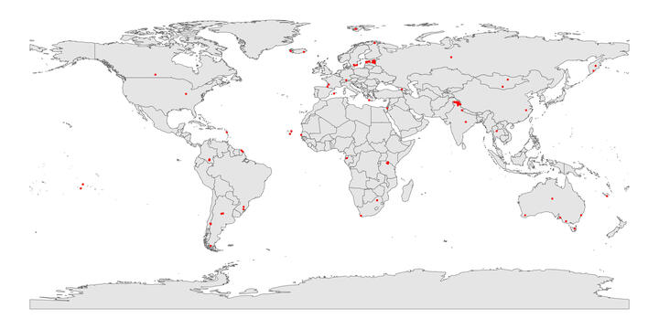
- Mycorrhizal fungal taxa that associate with individual plant species in MaarjAM
  - Doesn’t have samples so these are not “communities”
  - We can create a list of fungi for a location/site that are associated with a particular plant
  - Currently ~ 432 VT represented in the subset that has community data
- Alternative dataset - MaarjAM subset that holds sample-based data - i.e., community data
- Run these 2 datasets in parallel to see what the coverage looks like?
- At which level do we need the data?
  - If a plant associates with a fungus somewhere, is that ok to be combined
  - Can set boundary based on proximity (coordinates) or ecosystem
- We could have 2 global maps
  - FRED locations
  - MaarjAM locations
  - What proportion match on locations - are there challenges with scope of coordinate accuracy

Keep both dataset development going in parallel and move to those that have best coverage.
- Some QC still needed on the FRED side - check through some records to make sure nothing that stands out wildly.
- Preliminary analysis - is it worth going further? If so, we can go to deeper analysis

Science questions (Needed to evaluate is it possible/worth it!)
- Does root diameter influence which VT colonize? Hypotheses potentially based on …
  - AMF taxa that invest intra vs extraradically?
  - AMF taxa that are carbon hungry vs. carbon light
- Delineating AMF niches based on biotic resources = root availability niche
  - Example of AMF biomass in soil linked with plant DNA abundance in soil
  - How would that work with a gradient of root diameter as a niche dimension?
- Nutrient mechanisms - root N or other nutrients that drive linkage
  - To what degree do we have this kind of data in FRED?
    - Lots of these in the subsets in the newest pulldown from Teddy : Root N, SRL, Root P
- Distinction for root traits impacting root fungal pathogens vs. AMF
  - Probably don’t have this in many of the MaarjAM datasets
- Distributions for each in relation to local elements: land use, ecosystem, basic soil properties
  - MaarjAM has good 3 layers of ecosystems (primary: forest, agriculture; secondary: moist tropical forest; etc.)
- Modeling approach:
  - Each use the whole databases to predict root traits or VT distribution
  - For the overlap subset, does the inclusion of the other dataset improve the predictions? Why would they?
    - AMF influence root development and therefore can shift root traits in ways not clear from soil properties and plant species alone.
    - Root traits are a proximate control on VT distribution beyond soil properties and plant identity alone.
Example questions:
Do large diameter roots with colonization have particular taxa compared to small diameter
Are particular mycorrhizal taxa specific to (or generalist) on plant species with particular root traits?
- Starting of this with grasses, forbs, legume, woody, etc in MaarjAM paper

Setup Zotero and initiate database of literature

Next steps: ACTION ITEMS
- FRED team will officially decide which dataset to use
  - Likely will use one that has the most coverage
    - UPDATED COUNTS as of 20250416 (for species-level files)
      - Fine roots: 4, 161
      - First order: 144
      - 0-1 mm : 34
      - 0-2 mm : 1,589
      - 1st - 2nd order: 174
      - 1st - 3rd order: 85
      - Unspecified fine roots: 1, 750
- Map (from lat-longs) FRED data
- Luke will start a document with hypothesis statements - rest of the group add/modify
  - Ex. niche based
- Serra and Ben walk through for all sync/add Zotero database
- Next meeting May 7th - same time as this meeting
- Specify any activities from FRED or MaarjAM teams where individuals without specialized database knowledge can assist
  - Find papers to support underlying hypotheses being tested
  - Go through primary literature from which FRED/MaarjAM overlap subset are pulled to confirm or try to farm additional data
__________________________________________________________________________

STARTING QUESTIONS TO GUIDE ANALYSES

Does variation in fine-root traits across plant species lead to preferential associations with certain arbuscular mycorrhizal (AM) taxa over others? That is, do fine-root traits structure the communities of AMF that associate with them?

Challenge statement: Generally speaking, AMF are regarded as being generalists compared to many other fungal groups. For example, among ectomycorrhizal taxa, while generalists exist, there are many well documented cases of specialization including Suillus sp. primarily associating with Pinaceae, and some individual Suillus taxa being so specific as to associate with only 2 needle pines vs. 3+ needle pines. In contrast, most AMF are found with fairly wide host distributions. Despite the perception that AMF are generalists, and the relatively narrow taxonomic breadth covered by this group compared to other fungal guilds, there is still well documented diversity among AM taxa that should lead to ecological specialization. For example, the relative allocation of fungal biomass within vs. external to root tissues varies greatly among AM taxa, as does the proportional allocation of fungal resources to acquisitive hyphae vs. reproductive structures. While we can recognize the variation in traits among AMF, we do not have a framework to understand how or why certain taxa may be favored over others in different contexts, particularly with regards to variation in their carbon-supplying plant hosts. We hypothesize that variation in common root economic traits is associated with unique, or at least biased AMF communities.

Our analysis will focus on a set of commonly measured fine-root traits that are thought to be important both for the function of individual roots and root systems as well as the symbiosis with mycorrhizal fungi. Specifically, we will focus on the four core traits that define the root economics space (RES): root diameter and specific root length (SRL), root tissue density (RTD) and root nitrogen content (root N). In addition to these traits we will consider variation in root phosphorus content as well as percent mycorrhizal colonization, though this last trait may primarily be used as a covariate rather than a specific predictive trait.

Specific predictions:

Root diameter and specific root length: Large root diameters (and accordingly lower SRL) is strongly associated with larger cortex area which provides a larger area for colonization by mycorrhizal fungi. Previous studies have also indicated that species with larger diameter roots also tend to have higher colonization rates, particularly for AMF. From this, we may formulate two, somewhat contrasting hypotheses.

H1A: Plants with larger diameter (and lower SRL) roots will support the highest diversity of AM taxa with no clear discrimination against particular AMF while thinner roots will support lower diversity. This may occur due to the high reliance of thicker-rooted plants on the symbionts and the larger area available for colonization that minimizes exclusion of particular taxa. This relationship will be more strongly pronounced within plant functional groups (grasses, forbs).

H1B: Plants with larger diameter (and lower SRL) roots will be biased towards taxa that are known to have higher ratios of fungal biomass investment inside vs. outside the root while thinner diameter roots will be biased against these taxa owing to the reduced area for colonization within these roots.

H2: Availability of root space for colonisation (e.g SRL or abs. Root length?) will increase or decrease competition for habitat within AM fungal communities.

H2A: Low SRL plant root habitats create higher competition within AM fungal communities. This will result in fungal colonisation with “high root colonisation” species (possibly ruderal lifestyle?) that are quick to inhabit available root space.

H2B: Low SRL root habitats are preferentially inhabited by more nutritionally beneficial AM fungal communities (higher specialisation, more soil hyphae?) because the plant can select for these more economical fungi(?).

Root nitrogen content and root phosphorus content:

Root tissue density:

Fungal perspective by taxa (not community)
AM fungi also change plant root architecture (e.g., work by BAD Hetrick). AM fungal morphology differs across the phylum, for example with some taxa having hyphae more concentrated in root tissue vs soils (Koch et al. New Phyt. 2017). These fungal differences, however, may not have predictable effects on plant responses to the symbiosis. In the end, we can only assess whether there is a correlation between plant traits and AM fungal occurrence, not which causes the other. Here are two fungal-centric hypotheses related to this, although perhaps they are restatements of tanel.vahter@ut.ee and lmccormack@mortonarb.org’s above.

AM fungal taxa with morphologies concentrated in the roots will be more common in plants with extensive rooting systems, particularly those with fibrous roots. These plants have many fine roots that functionally overlap with the role of AM fungal hyphae extending into soil. As such, AM fungi that are more aggressive colonizers will be preferred.

AM fungal taxa with morphologies concentrated in the soil will be more common in plants with relatively simple rooting systems, for example Lilies, Irises, Asparagus, and Alliums. These plants may derive a greater proportion of their soil-derived nutrition via AM symbioses, with greater benefits from AM taxa that create more extensive soil mycelia to facilitate uptake.

First exploratory analyses in Ecobank (reduced MaarjAM) and FRED (Tanel) 06/05/25

Some of our questions & hypotheses require community data while others do not. I have started with EcoBank, which holds community data, as this was quicker to carry out in practice.

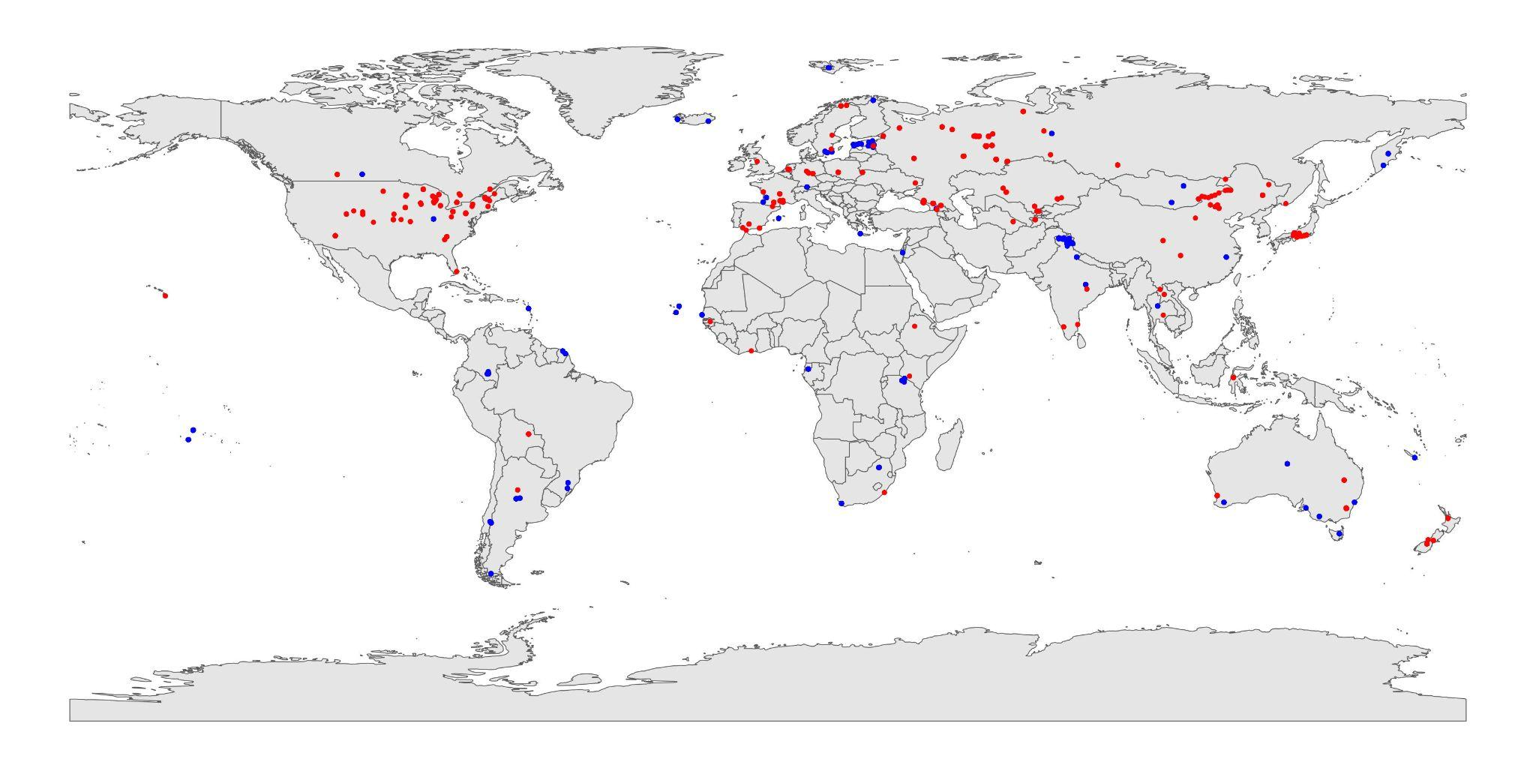
Fig.1 Red is for Fred - blue is for ecobank.
Seems that the coverage does vary quite a bit between databases, but there are common areas. We can approach this as necessary if the data looks like it will not work ‘as is’.

From here on, I extracted common plant species from FRED (fine roots) and EcoBank, which yielded 83 species (2020 observations from FRED and 882 observations from EcoBank). A lot of the plant species had a different set of root traits available and these were brought to mean values by species. This yielded around 30 plant species for each root trait (SRL,RTD, RD & RootN).

From here on, I have looked at mean root traits vs mean raw AMF richness and the mean proportion of cultured AMF taxa sequences (proxy for ruderality) in the community. I similarly divided AMF taxa into ancestral, rhizophilic and edaphophilic guilds according to Weber et al 2019 NewPhyt, gave each plant species a mean proportional abundance of each AMF guild by sequences and proceeded with similar comparisons to root traits, as previously. All proportions are logit transformed.

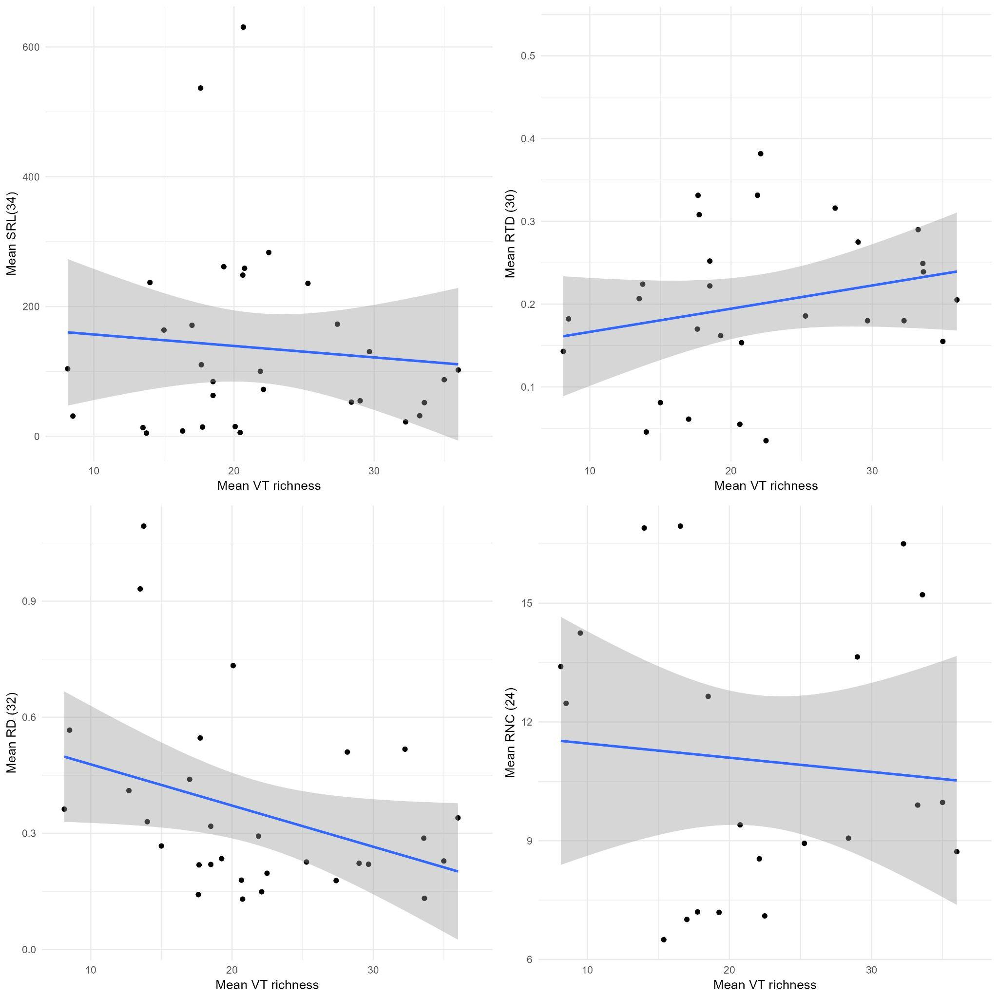
Fig.2 Mean species (VT) richness per sample by specific root length (SRL), root tissue density (RTD), root diameter (RD) and root N content.. Numbers in parentheses denote number of species that had both the root trait and AMF richness data.
It isn’t a huge number of species, so the data isn’t looking amazing, but there is a tendency for richness to be higher in thinner root systems.

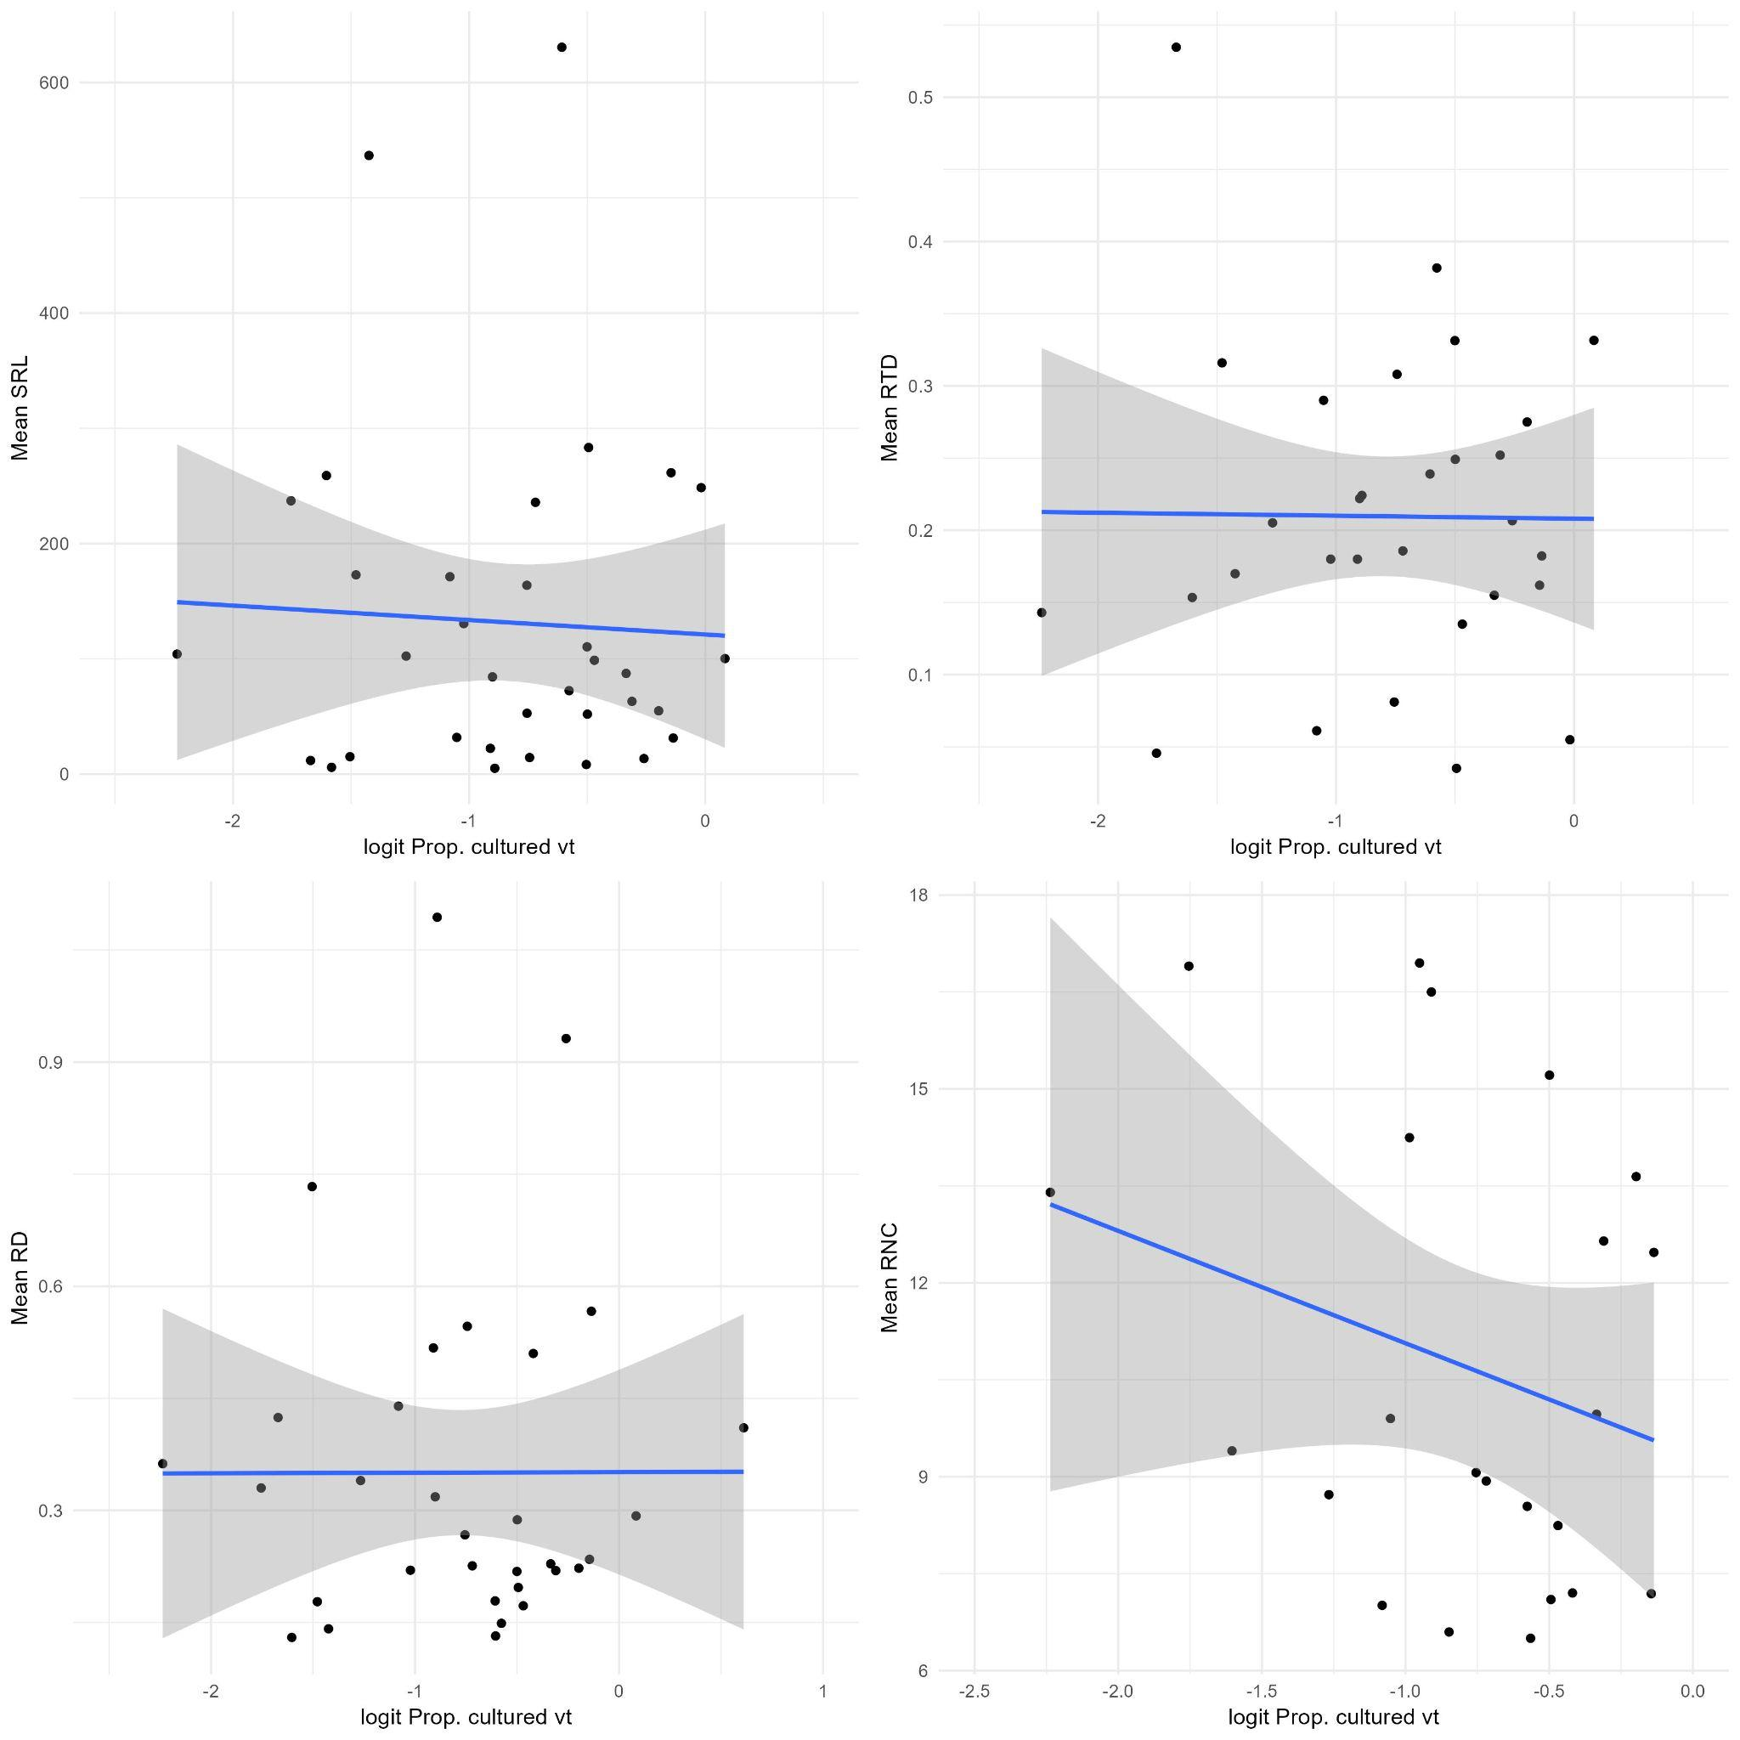
Fig.3 Proportion of cultured or ruderal AMF species for plant species and their root traits.
Nothing really here. Worth trying if presence-absence would give more strong relationships.

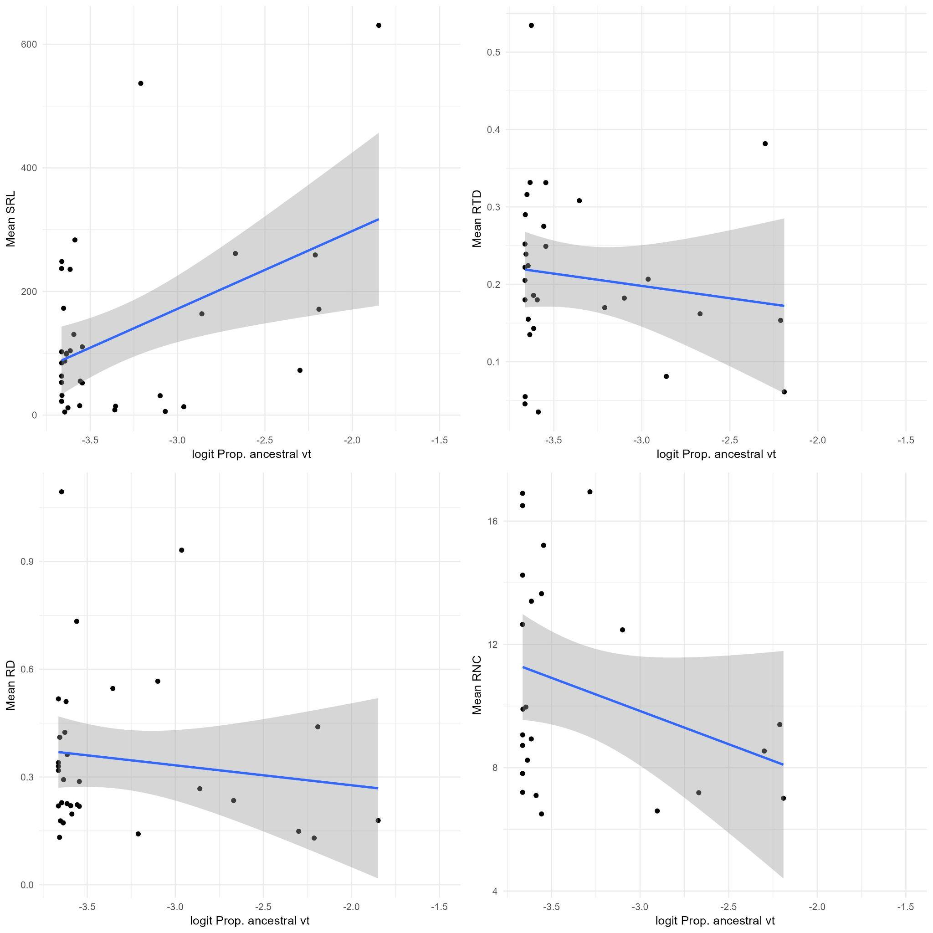
Fig.4 Proportion of ancestral AMF sequences and root traits

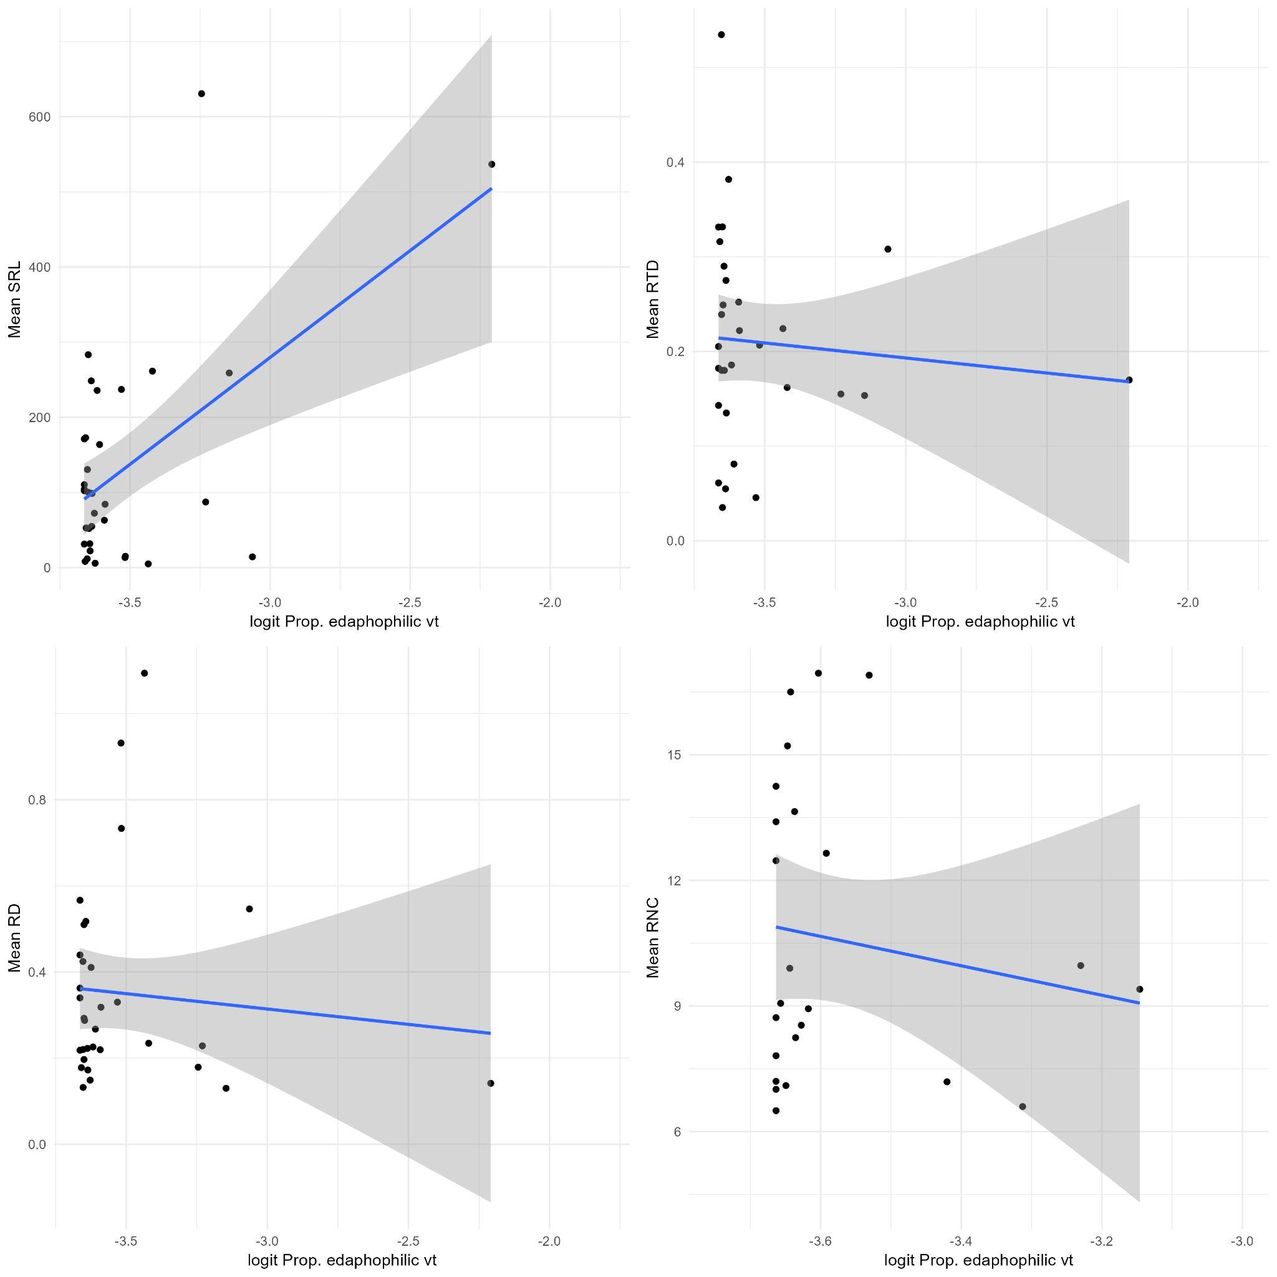
Fig.5 Proportion of edaphophilic AMF sequences and root traits
Higher SRL means more AMF that rather produce soil hyphae
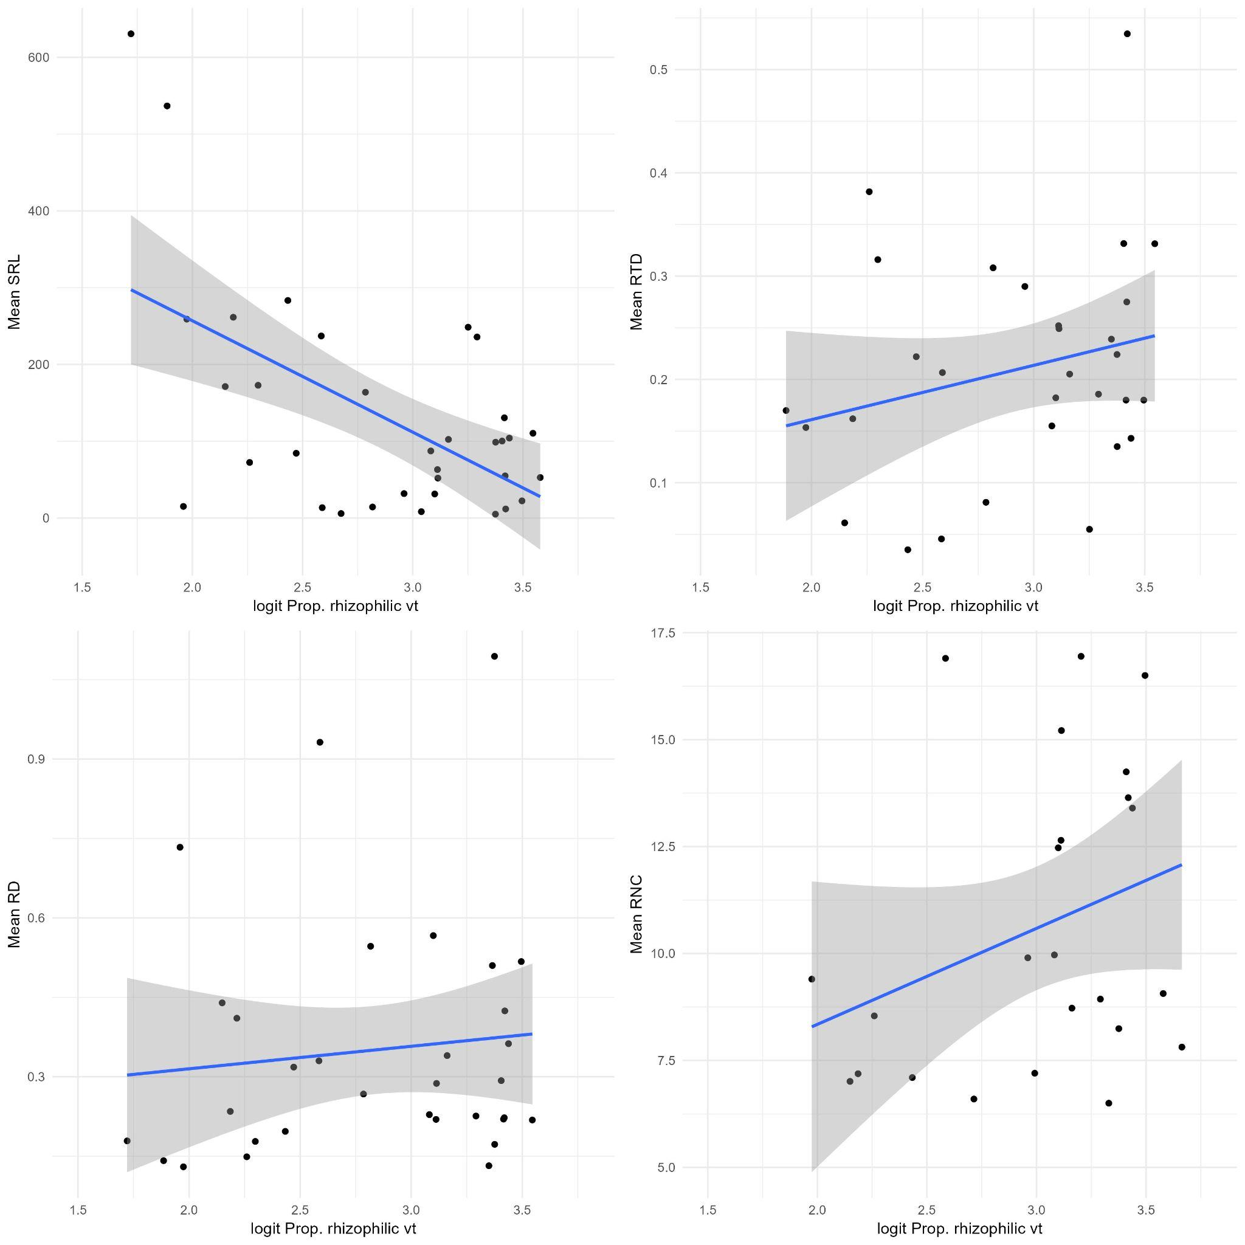
Fig.6 Proportion of rhizophilic AMF sequences and root traits
Higher SRL means less AMF that rather produce root hyphae

MaarjAM and FRED - presence/absence based exploratory analyses

Overlap between plant species with fine root traits in FRED and MaarjAM is 252 unique species. Including only overlapping plant species, MaarjAM retains ~25000 records

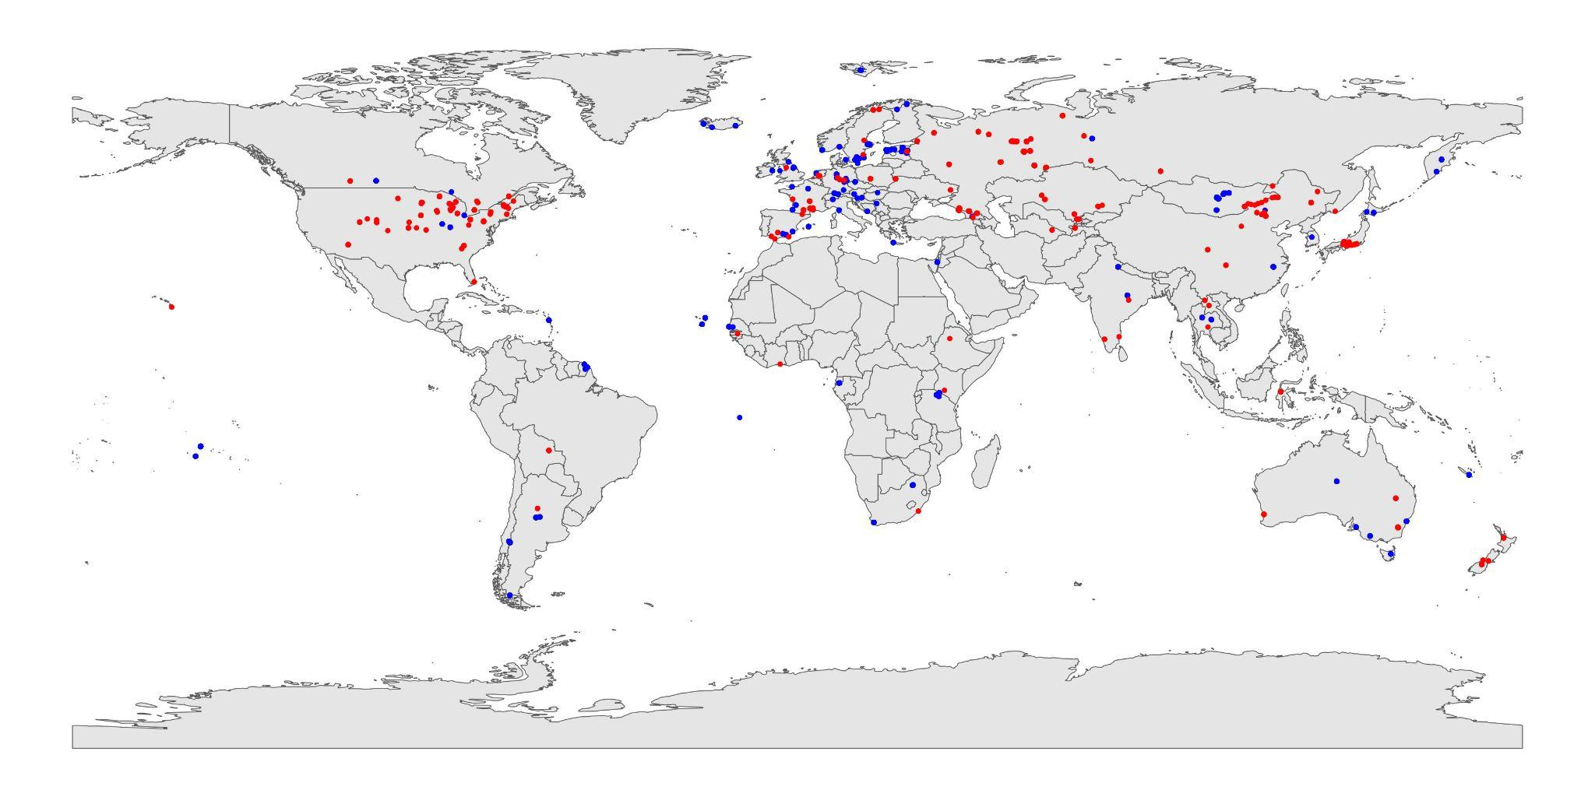
Fig.7 Red is for FRED, blue for MaarjAM records.

I then repeated the above visualisations with guilds using presence-absence, rather than proportional abundances, of VT-s. This is probably more like something we will get from MaarjAM - i.e what species of AMF have been found with which plants.

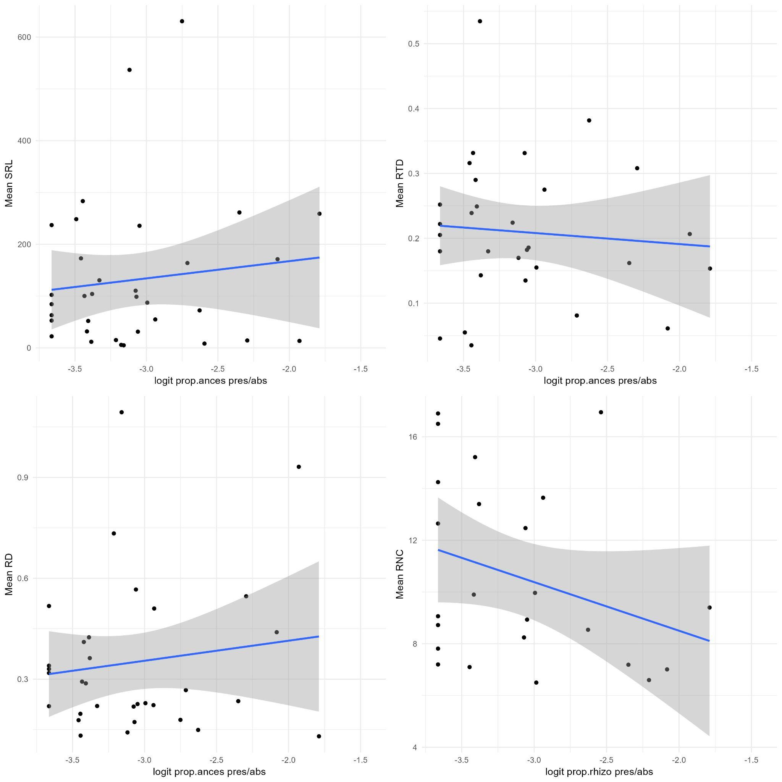
Fig.8 Proportion of ancestral AMF taxa by presence-absence vs root traits.

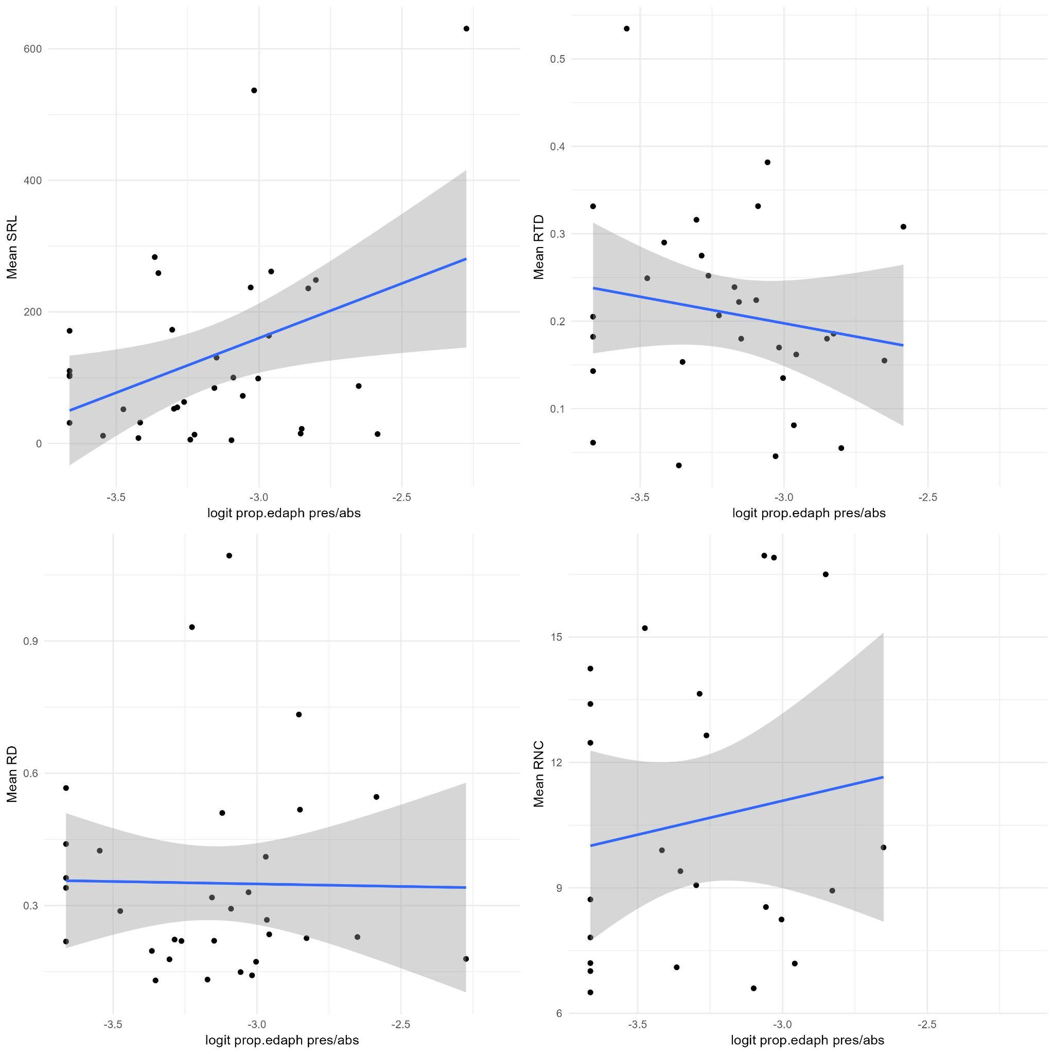
Fig.9 Proportion of edaphophilic AMF taxa by presence-absence vs root traits.
Higher SRL means more AMF producing soil hyphae
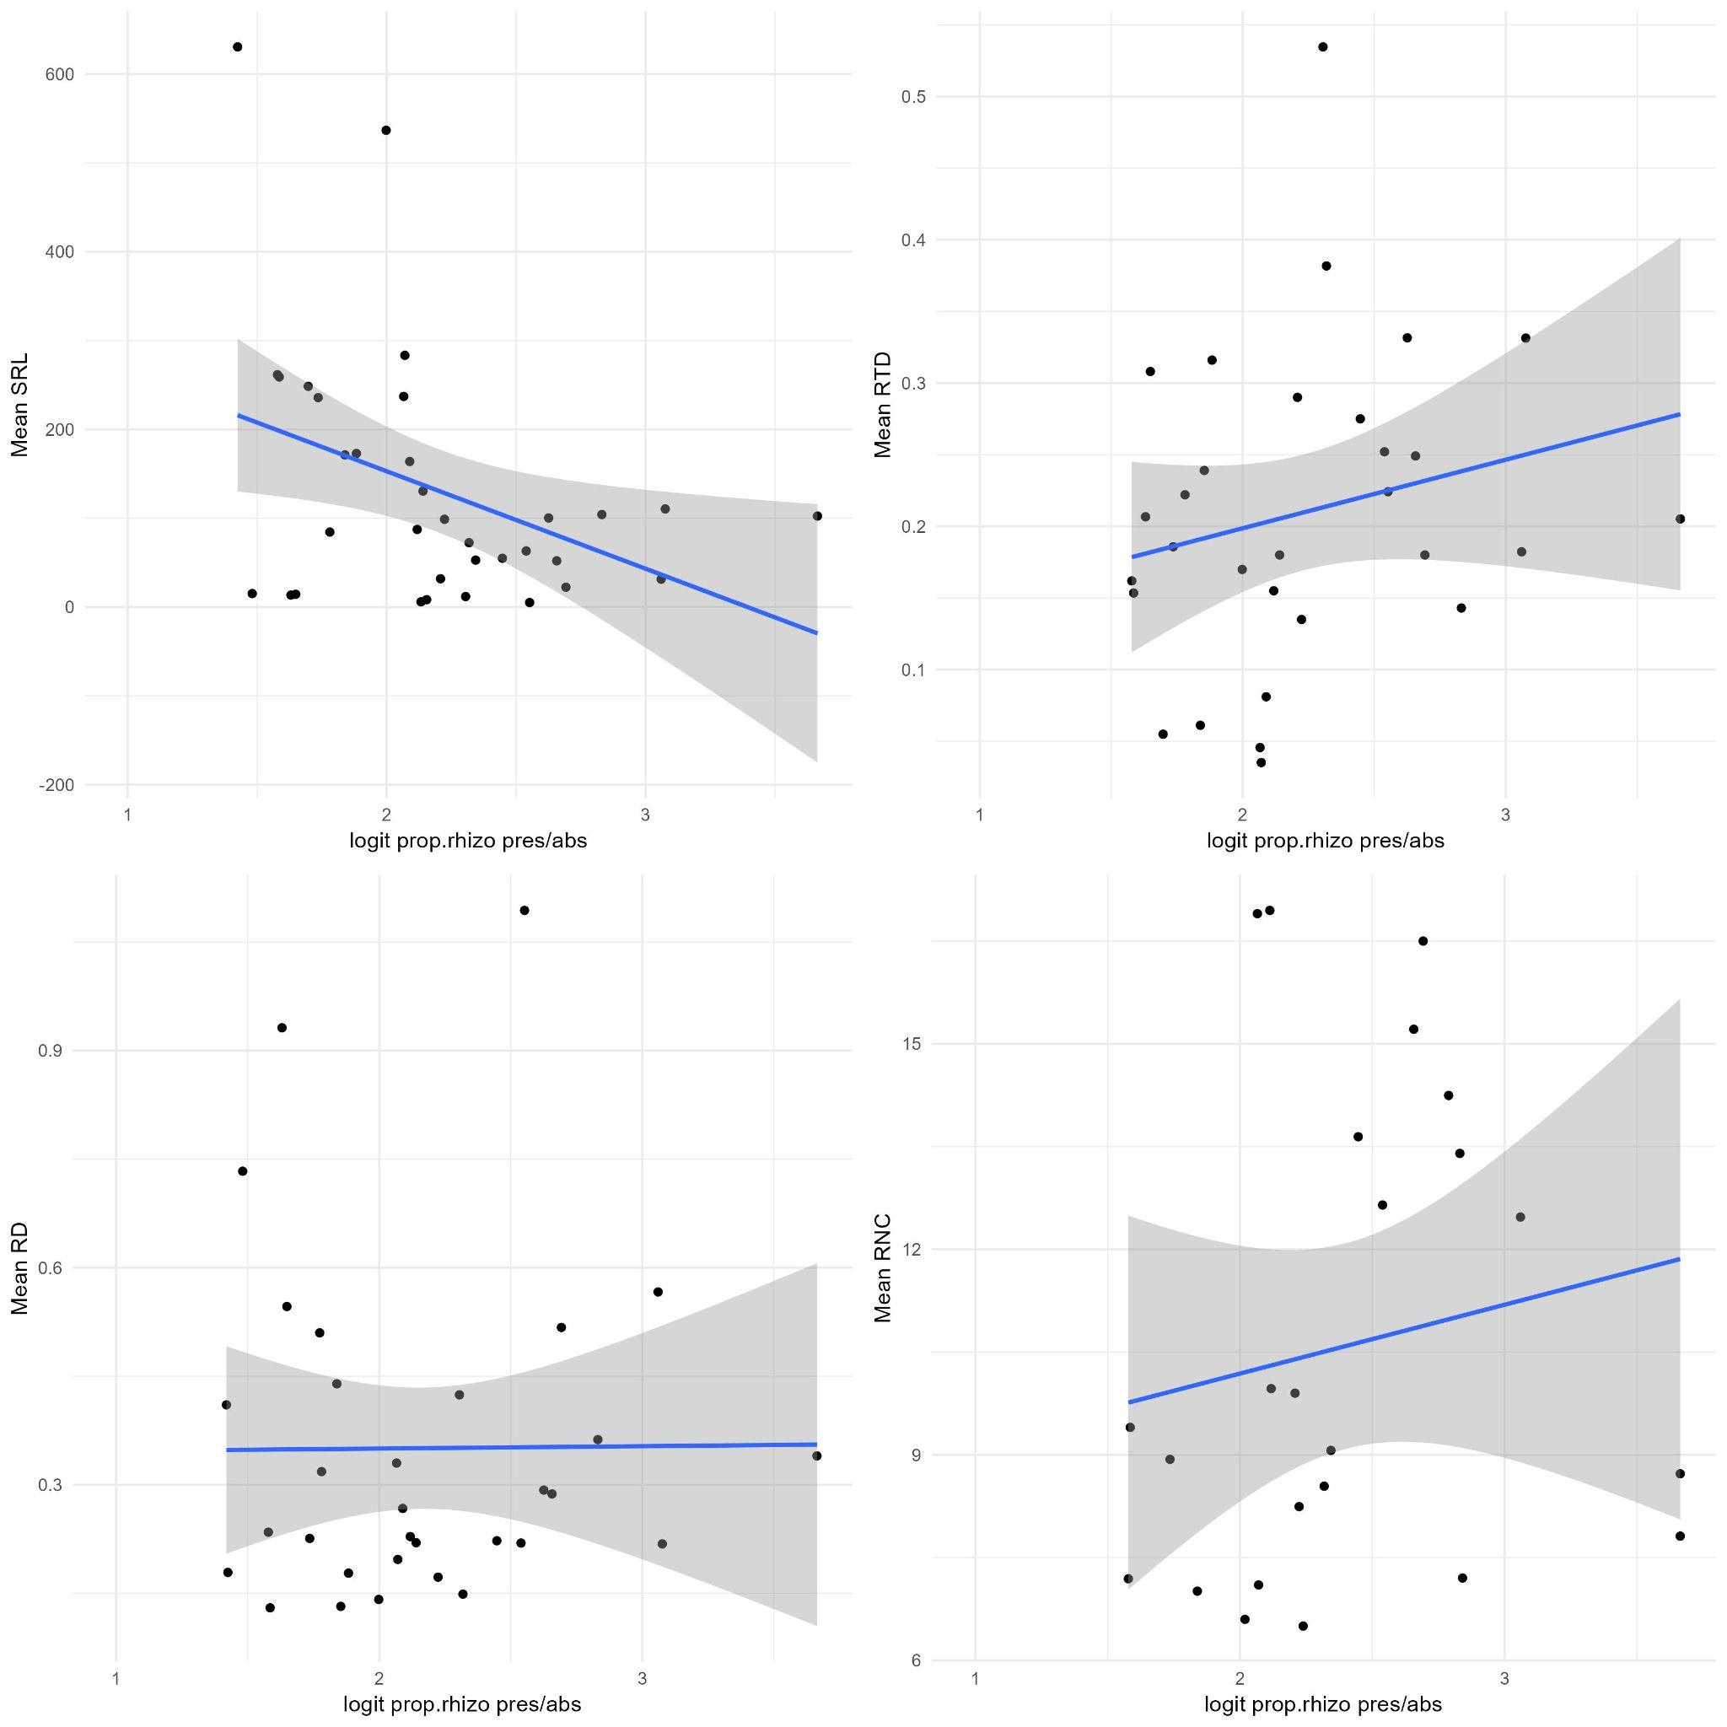
Fig.10 Proportion of rhizophilic AMF taxa by presence-absence vs root traits.
Higher SRL means less AMF producing root hyphae

Plant genus level exploratory analyses 09.06.25

Extracting maarjam plant genus level virtual taxa (presence/absence) and pairing them up with FRED mean genus level fine root data.

MaarjAM has AMF data for 451 plant genera
FRED has fine root traits for 136 plant genera
Overlap: 124 genera

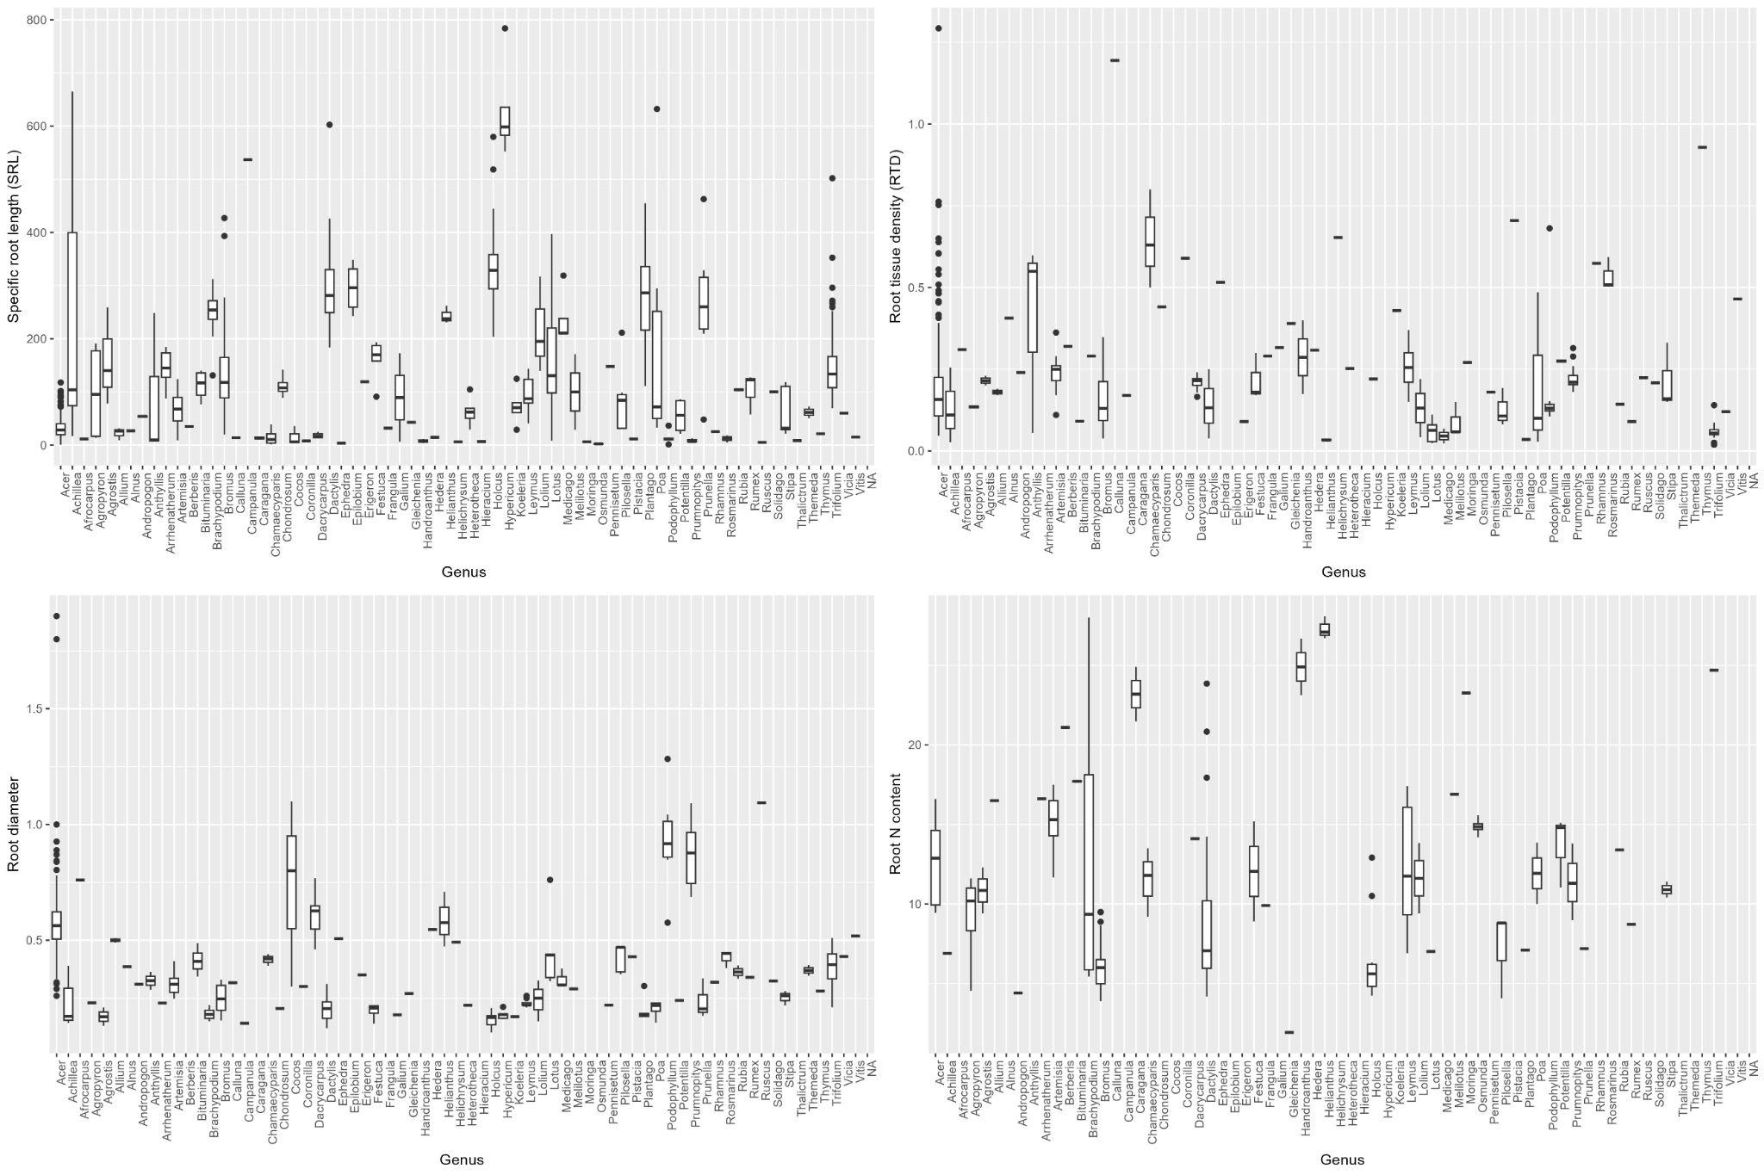
Fig. 11 Overall look at fine-root trait variability within genera in FRED. It’s super small letters because there are many of them, but it seems that some genera have quite large root trait variability, while others do not. This could be related to just the number of observations, also, but we’ll see. This needs some discussion!

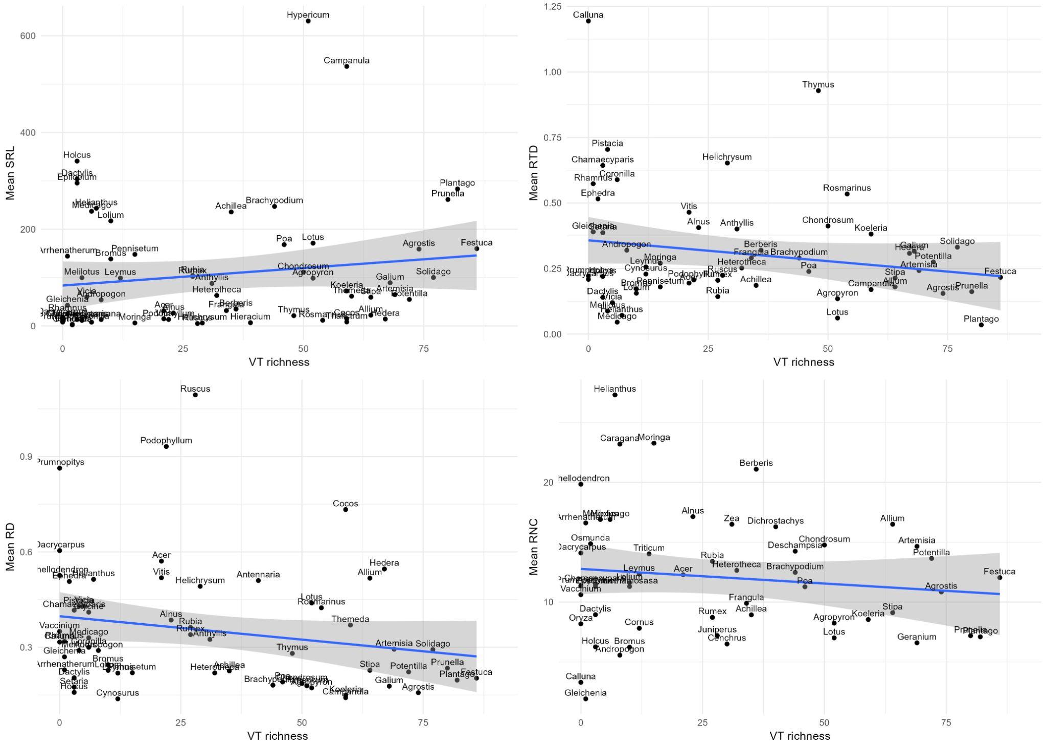
Fig. 12 Presence-absence based VT richness for four mean fine root traits by genus. The slopes aren’t very steep, but modelling would reveal the truth. I put the names here for ha-ha’s

Following figures show presence-absence based proportion of culturable VT, ancestral, rhizophilic and edaphophilic taxa vs mean fine root traits.

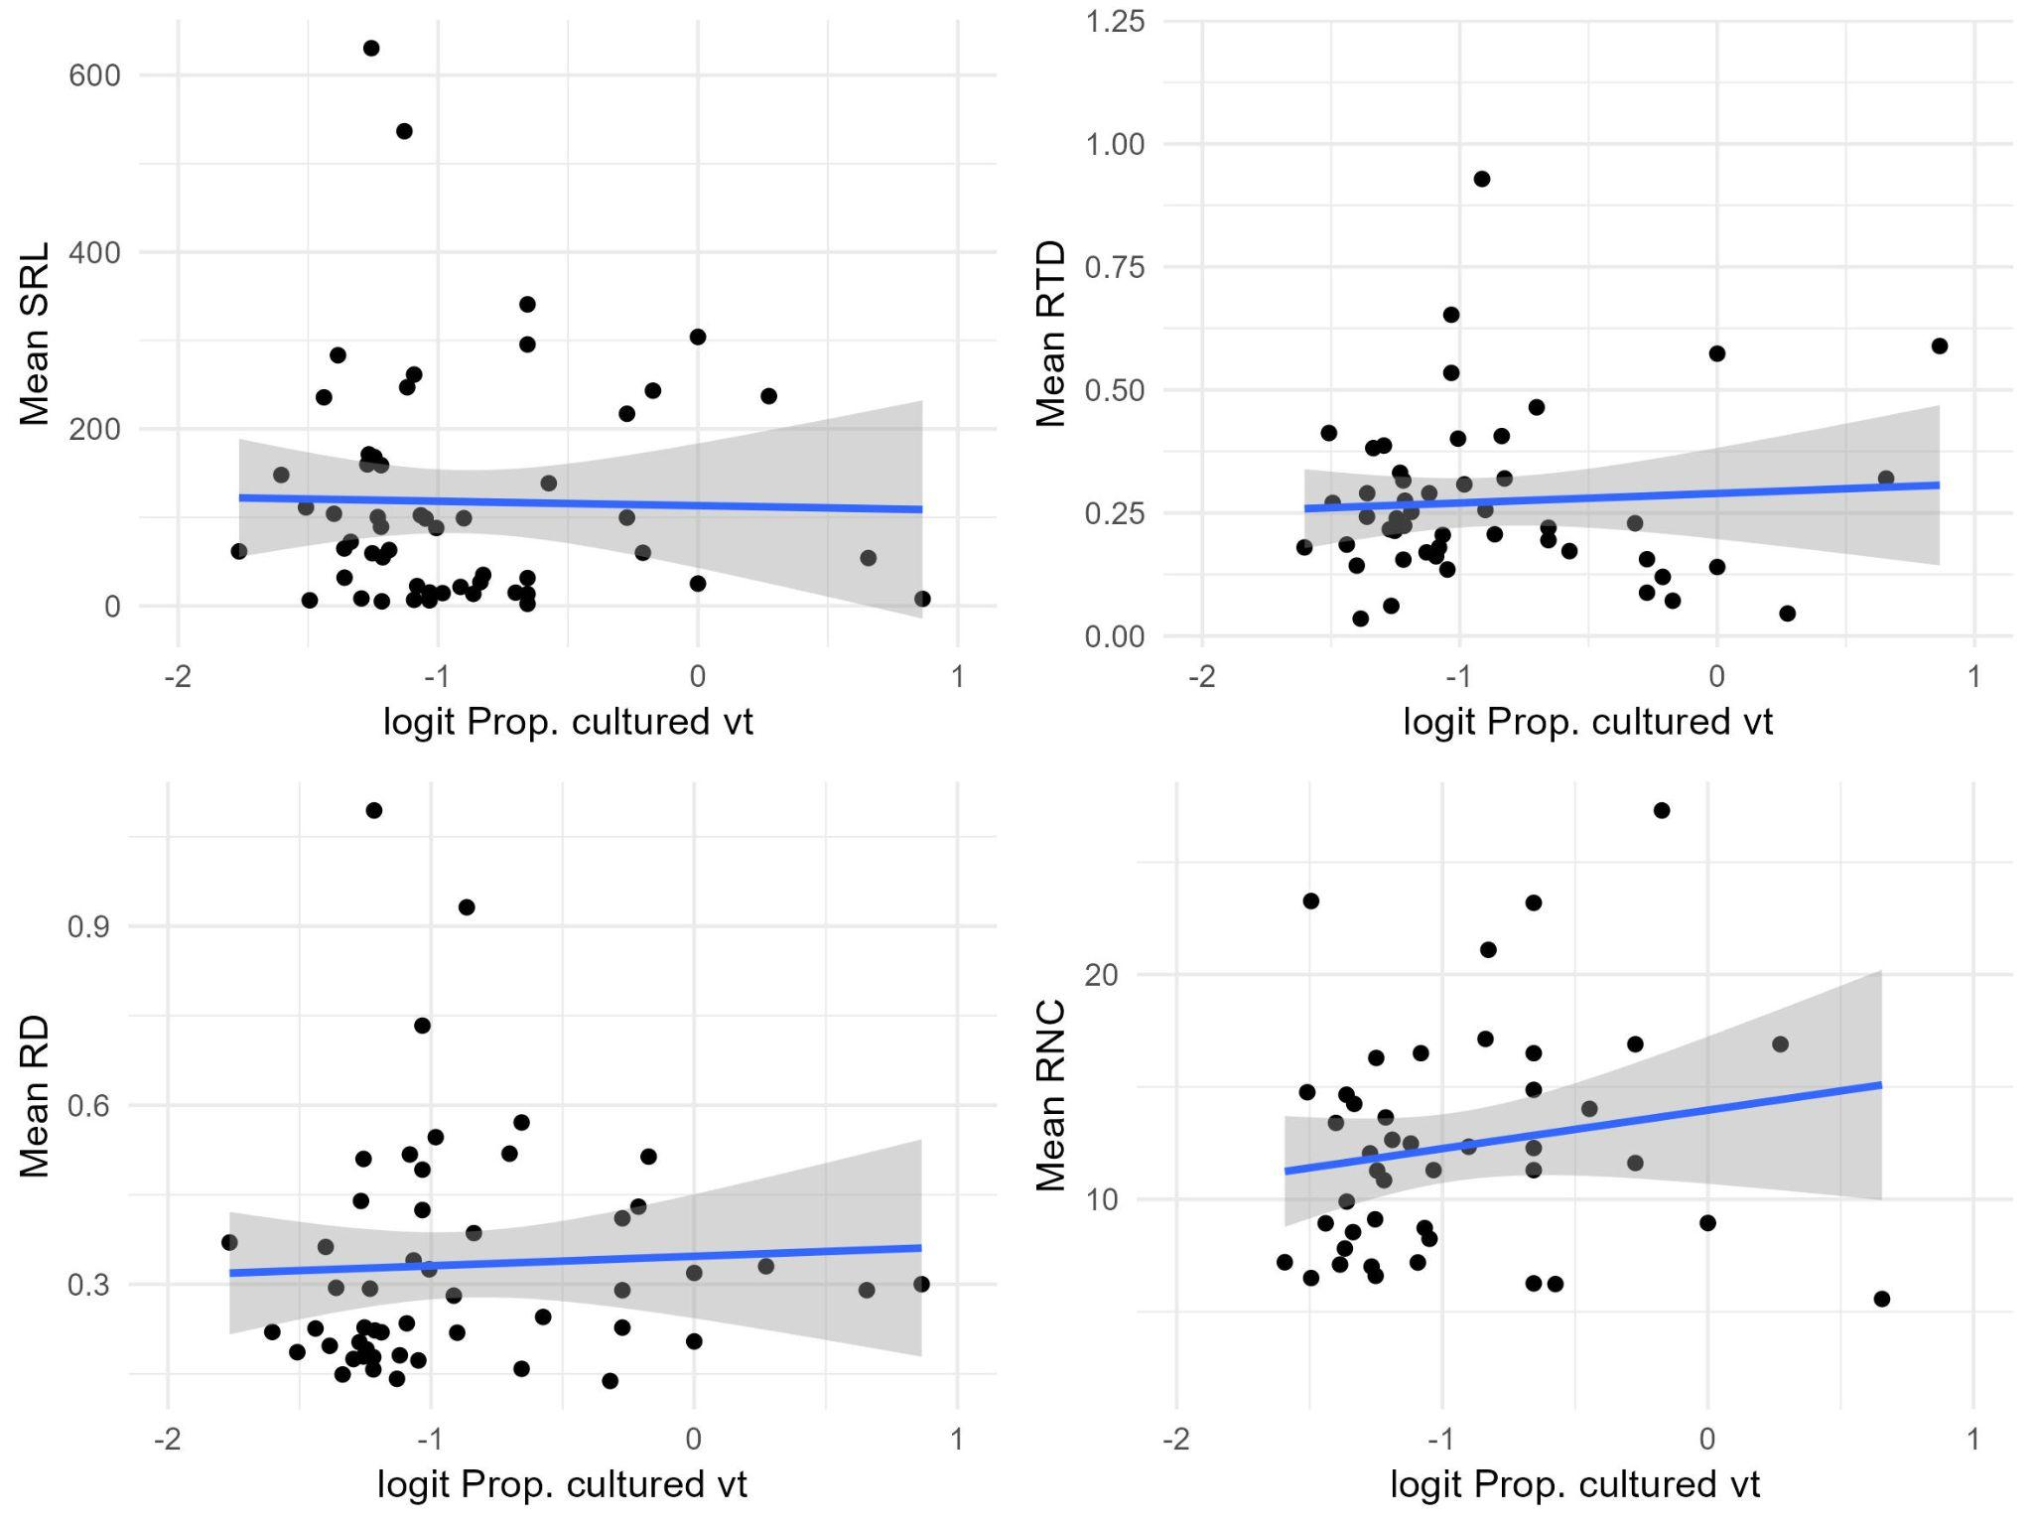
Fig. 13 Proportion of culturable VT and mean fine root traits at genus level

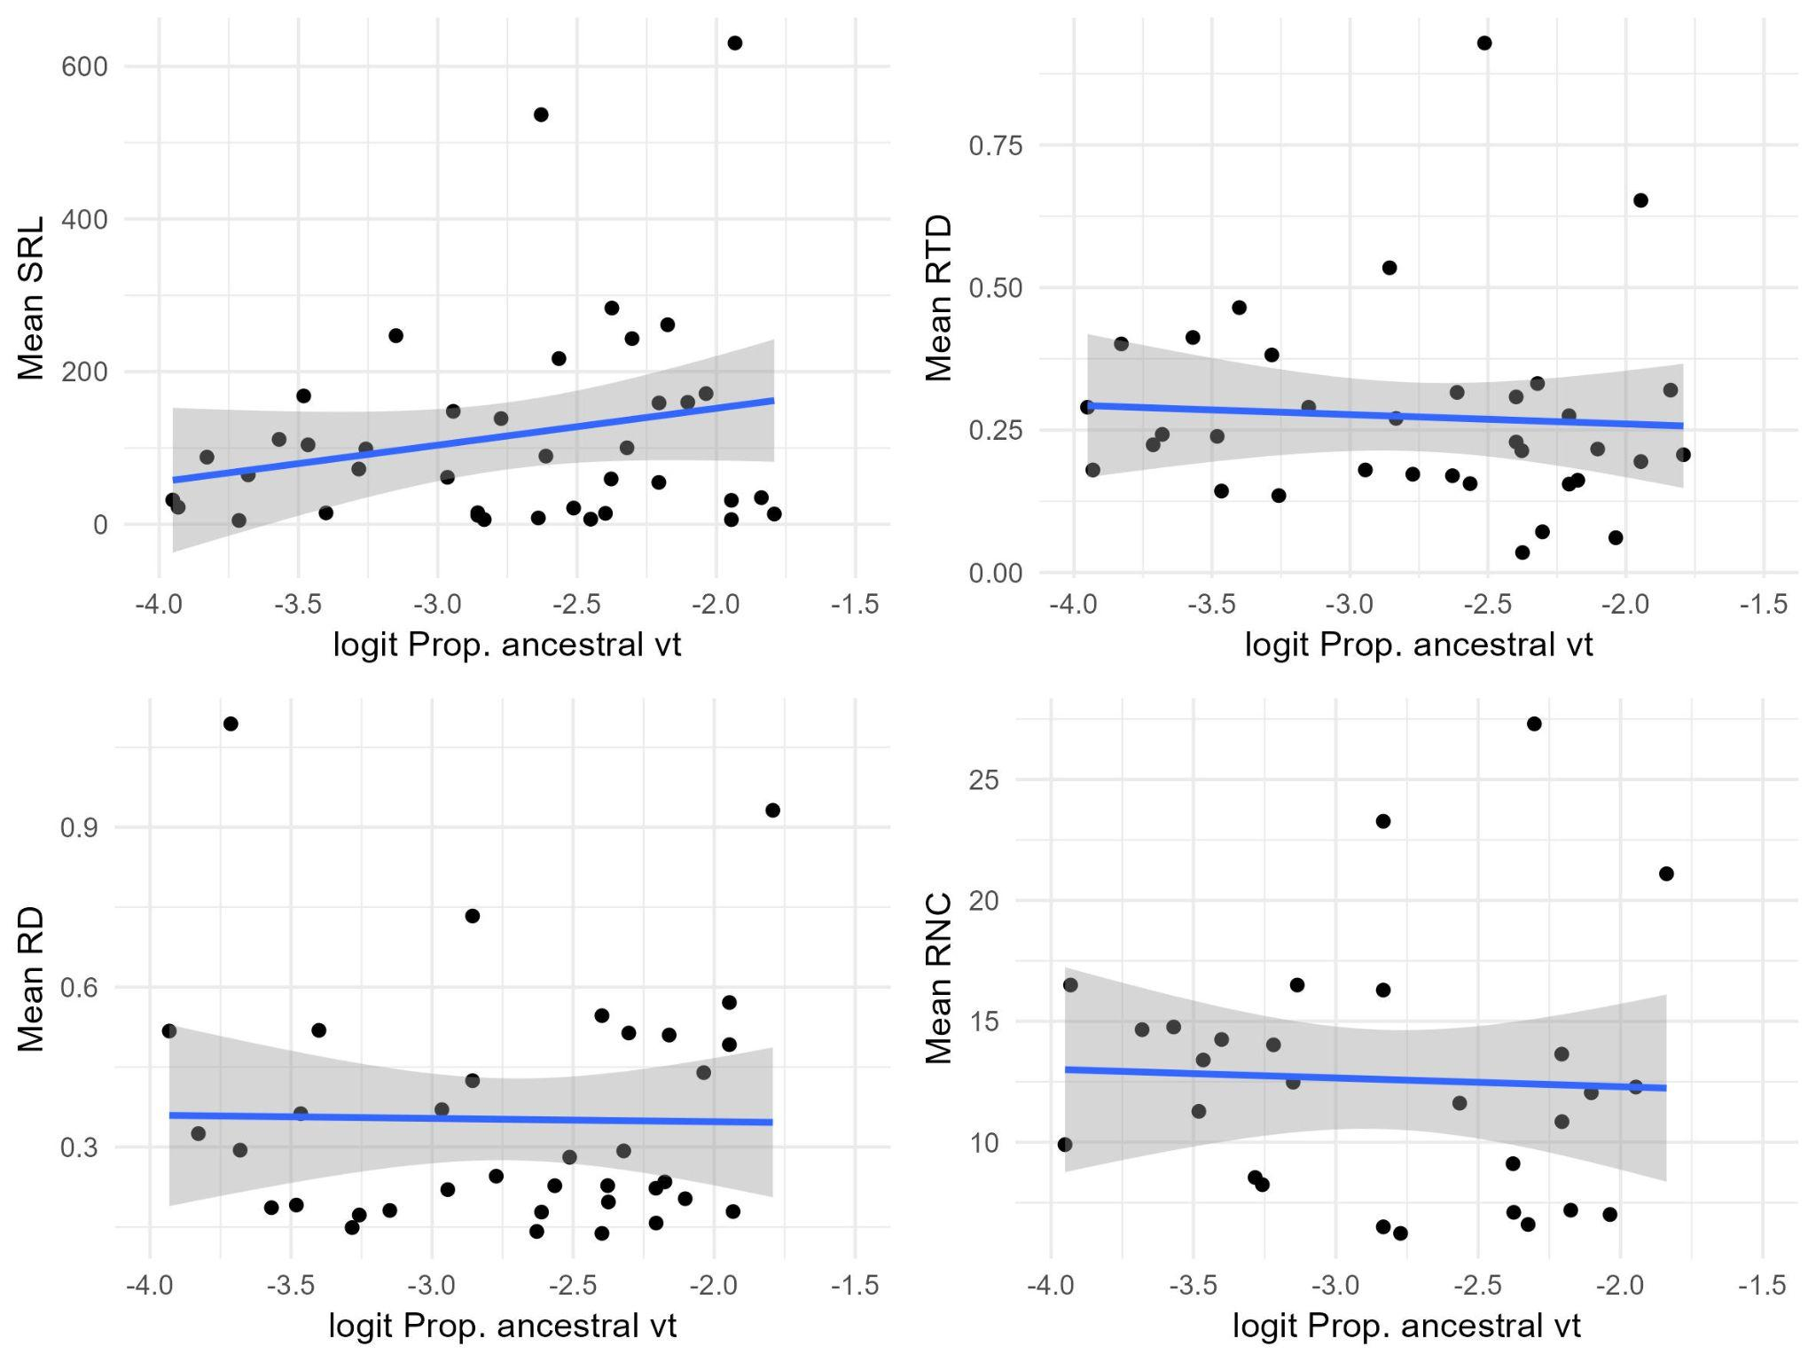
Fig. 13 Proportion of ancestral VT and mean fine root traits at genus level

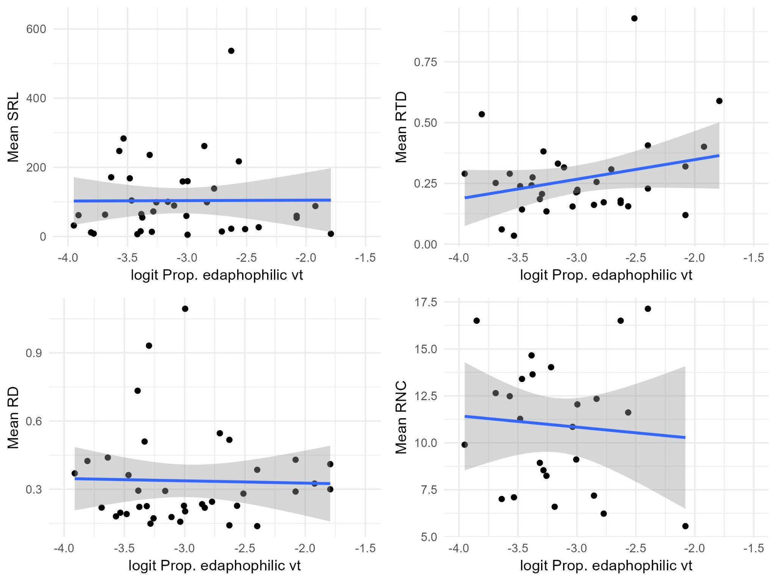
Fig. 14 Proportion of edaphophilic VT and mean fine root traits at genus level

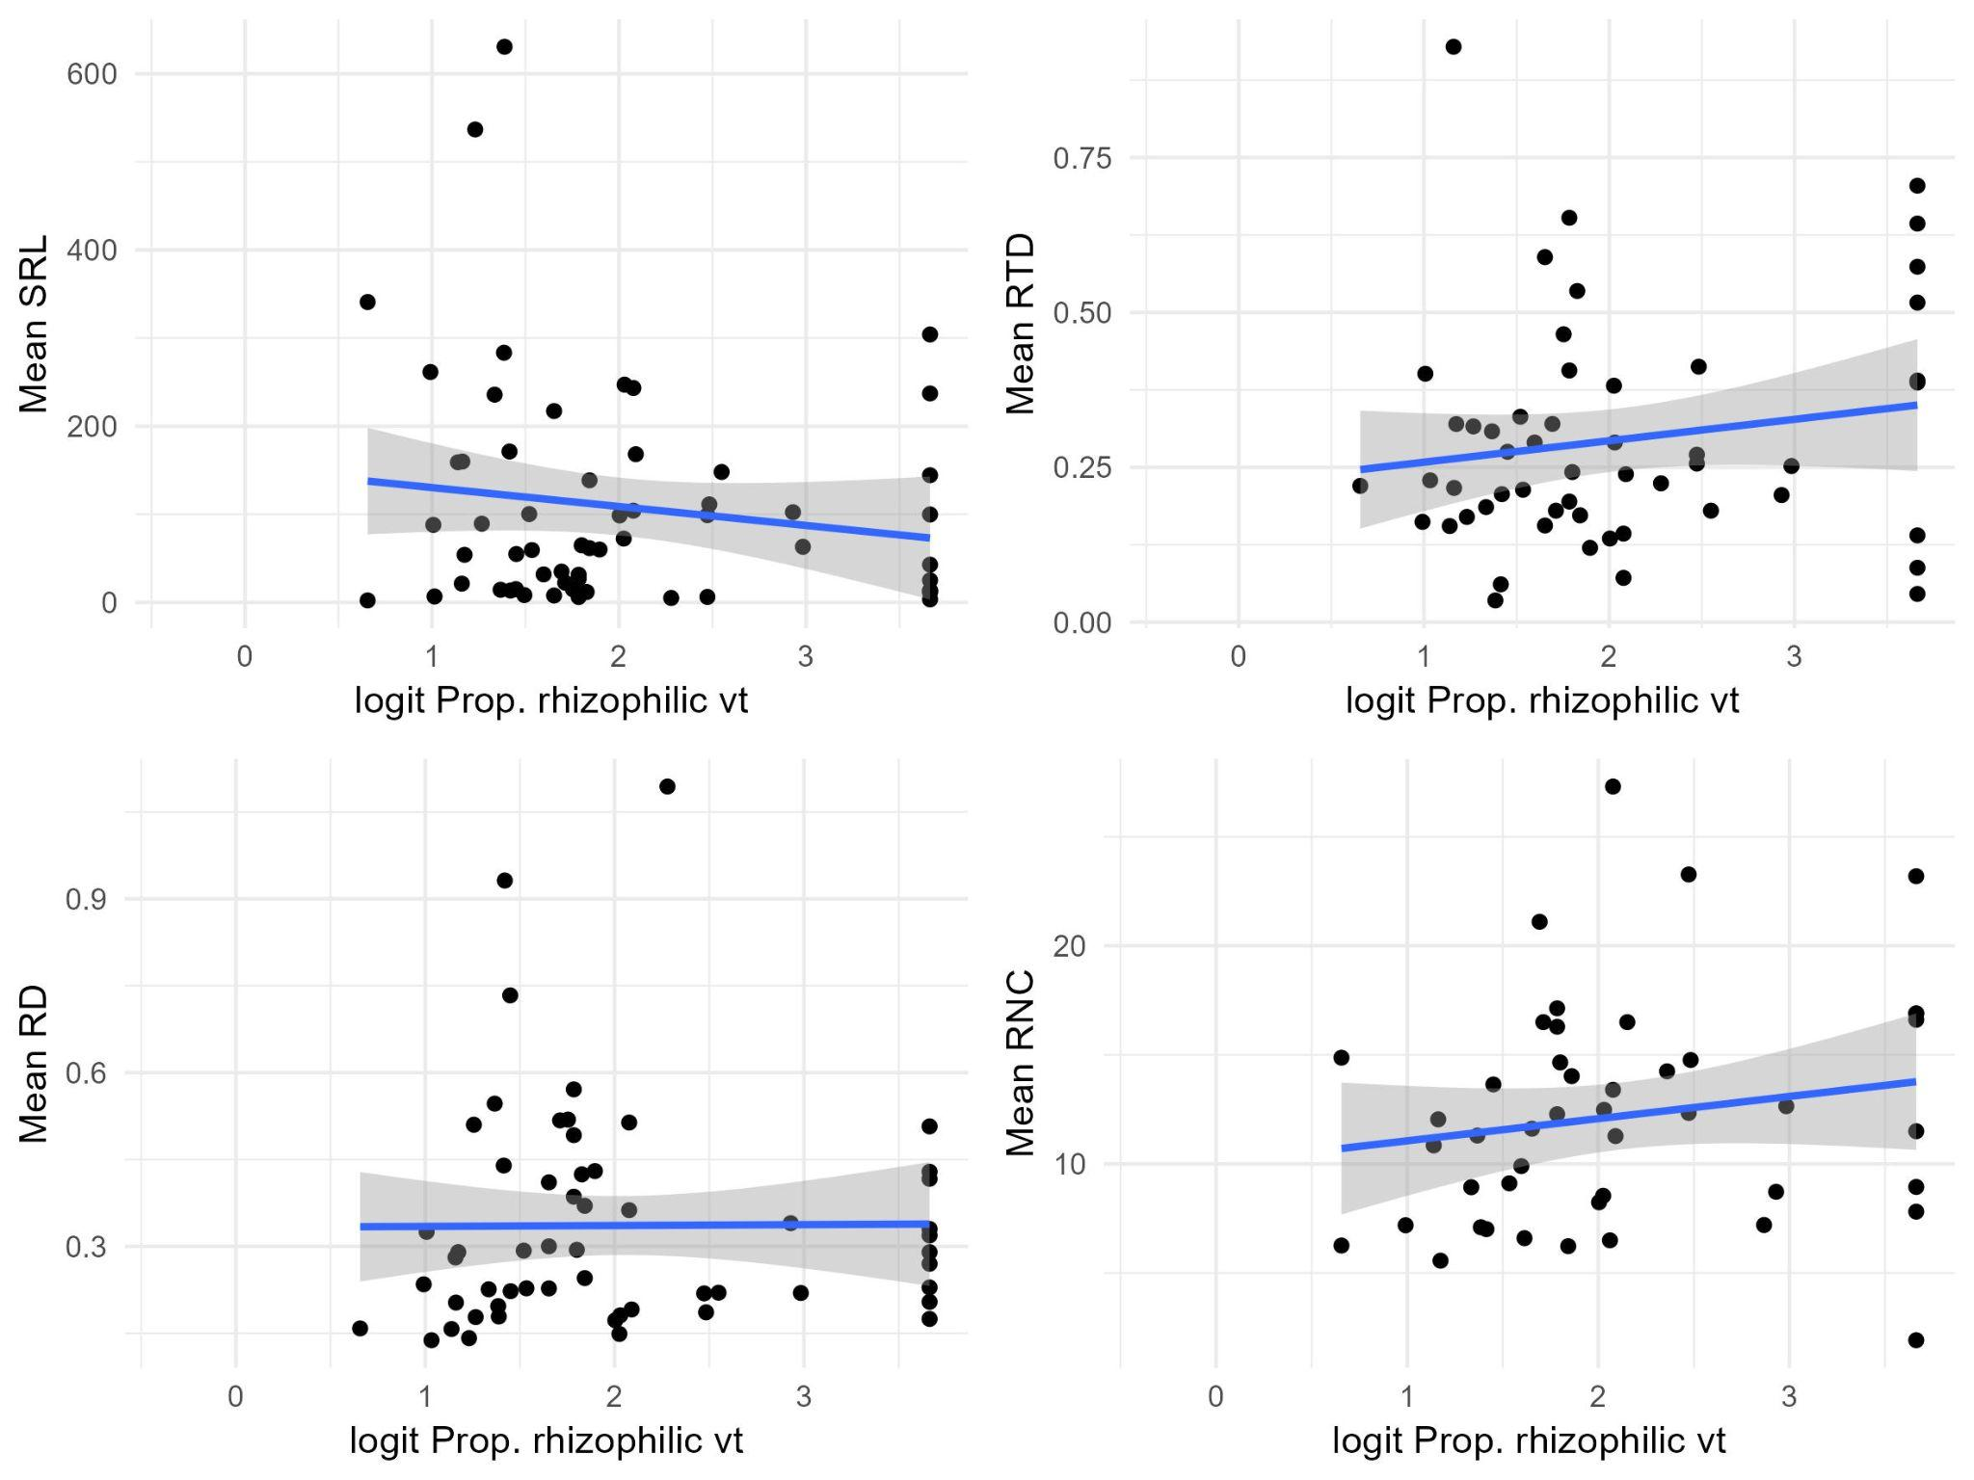
Fig. 15 Proportion of edaphophilic VT and mean fine root traits at genus level. Note - quite many had 100%

Summary Table of Current Results 06/11/2025

Table 1. Overview of the direction of relationships depending on the data pool of AMF used. + indicates a positive relationship, - indicates a negative relationship. 0 means a pretty flat slope. PS: no models, just direction of relationship. Overlap is total, individual traits may have less species/genera
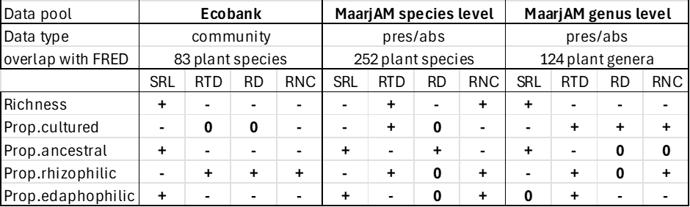
Conclusion: genus level gets us much more data, but it is also messier. Perhaps some hypothesis-driven filtering should also be done, i.e by plant life forms or something else. Also, the directions of patterns can be pretty different, depending on what data we use =)

What is consistent in all three datasets
Richness: - with RD and RNC
Prop.cult: - SRL
Prop.anc: - RTD + SRL
Prop.rhiz: - SRL + RTD and RNC
Prop.eda: none

Notes for next steps:
- Tanel’s suggestion to do some hypothesis driven filtering is good
- Once we decide what dataset to use/focus on (i.e. Ecobank, MaarjAM species or genus), AND, once we have the final version of FRED that we’ll use, we should line up taxa to identify our overlap and then run a few preliminary explorations
  - What proportion is woody vs. herbaceous
  - Check to see if we have a high proportion of N-fixers (I assume we won’t but need to check
  - Do a PCA of the 4 root traits that we have for those overlapping species to check whether we have expectations of a typical RES met
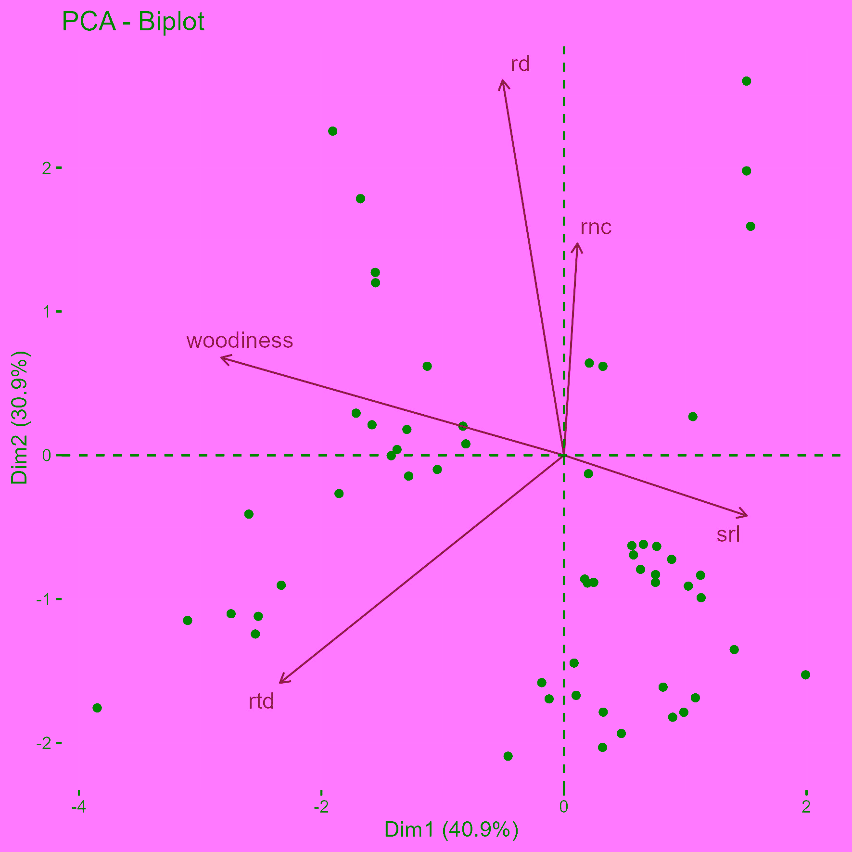
Fig. 16 PCA of fine root traits for genera included in previous analyses. Only genera with full coverage of root traits (57) included here. Indeed RTD and RNC are opposing traits. I also added woodiness. Woody genus = genera where at least some species are woody. Non-woody = 100% non-woody.
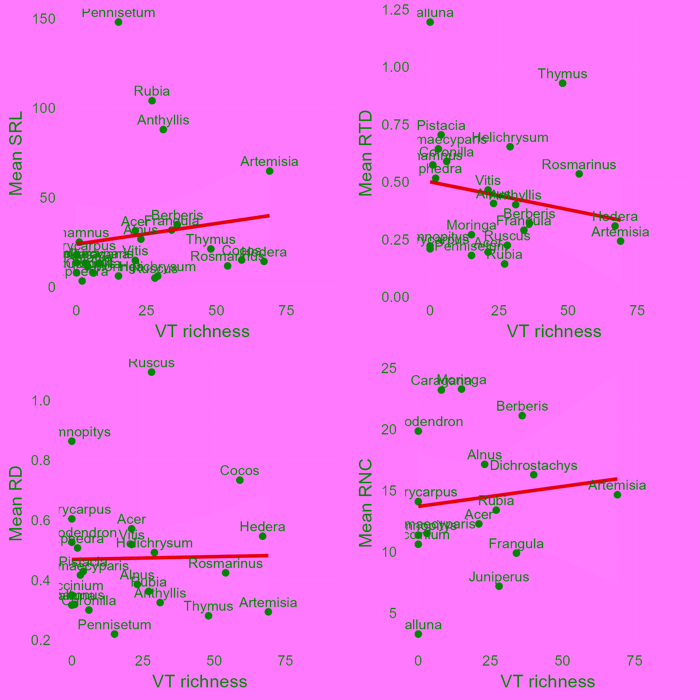
Fig. 17 Woody species root traits vs VT richness

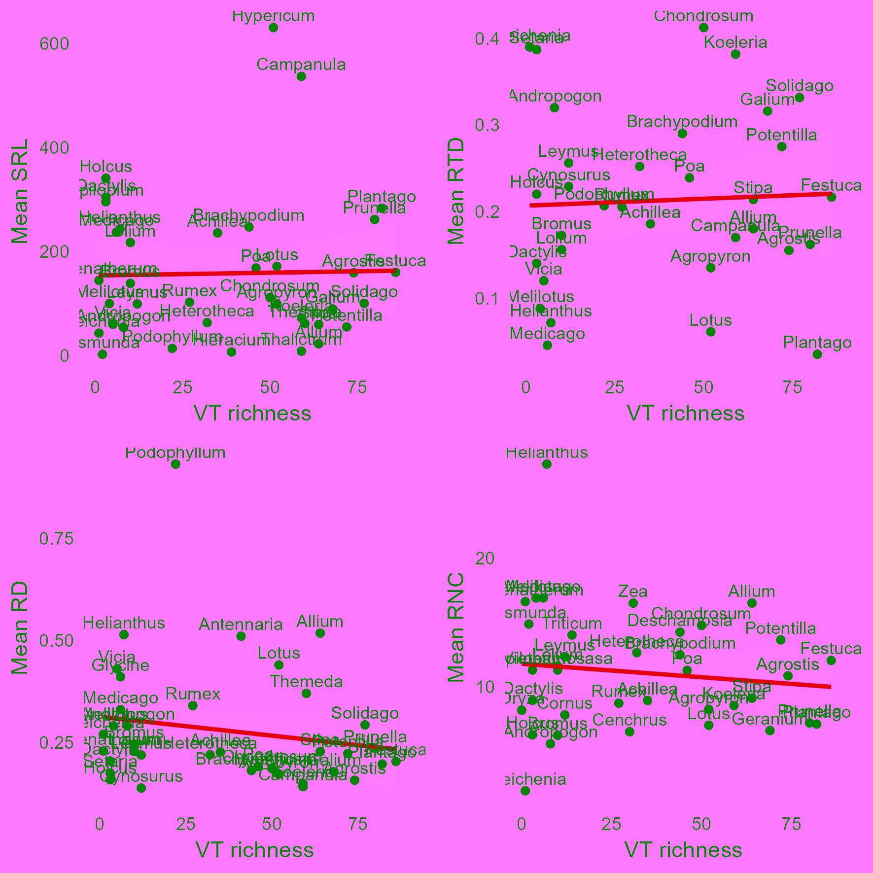
Fig. 18 Non-woody species root traits vs VT richness

Trends for woody genera appear to be different to non-woody genera. Go figure =).

BONUS PLOTS!
FungalRoot database (Soudzilovskaia et al., 2022), which has root colonisations, vs FRED
Overlap is 141 species of plants.

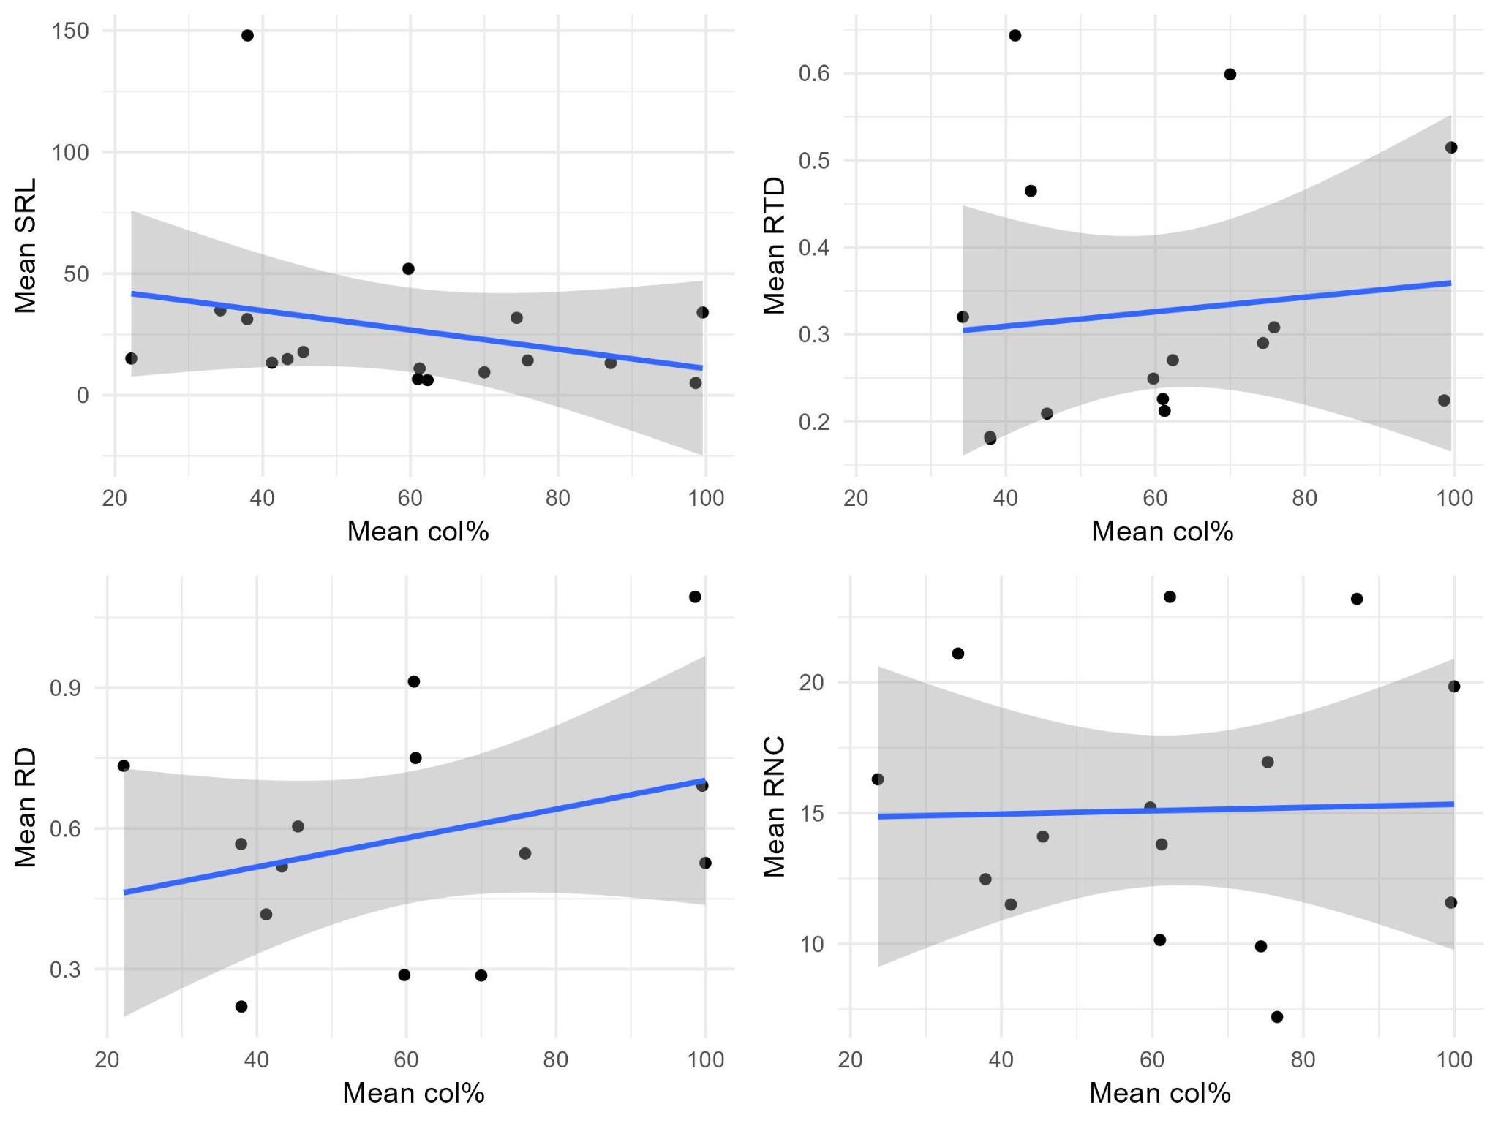
Fig. 19 Woody species mean colonisation and fine root traits

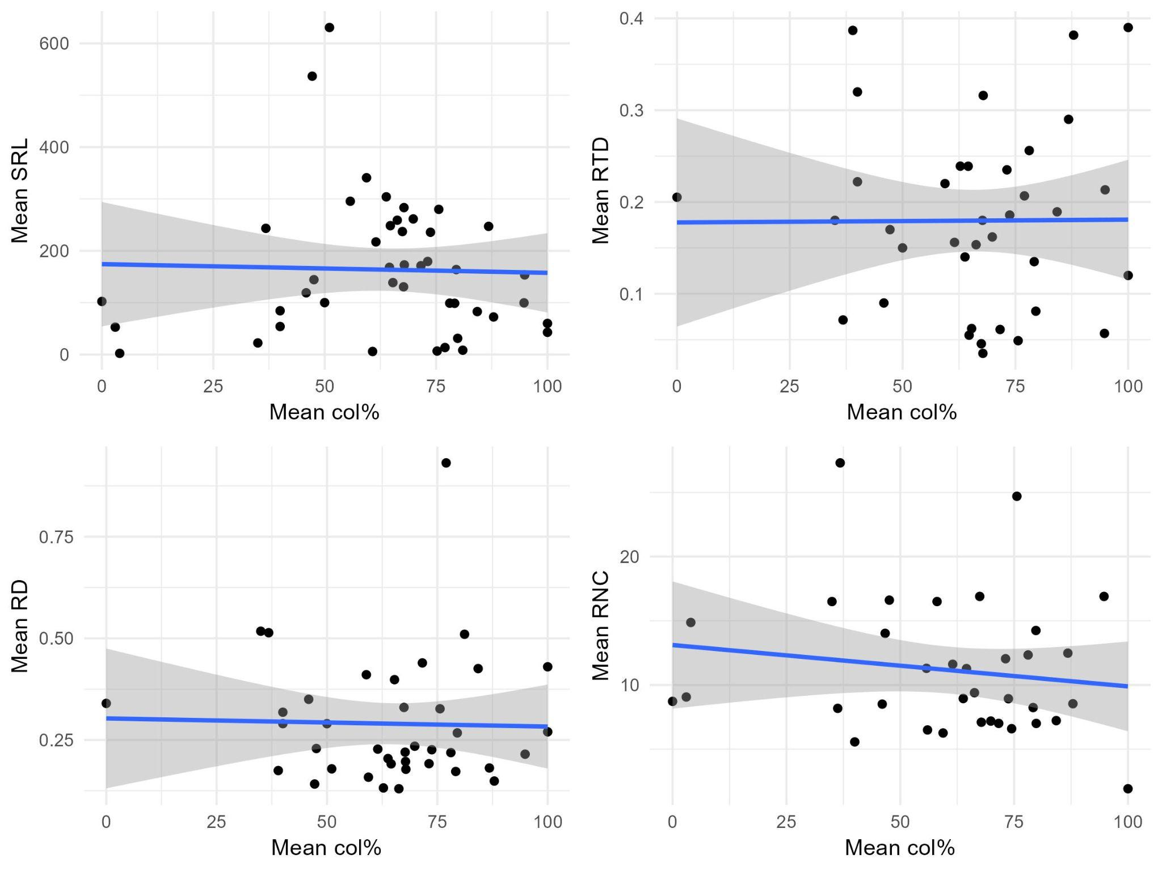
Fig 20 Non-woody species mean colonisation and fine root traits

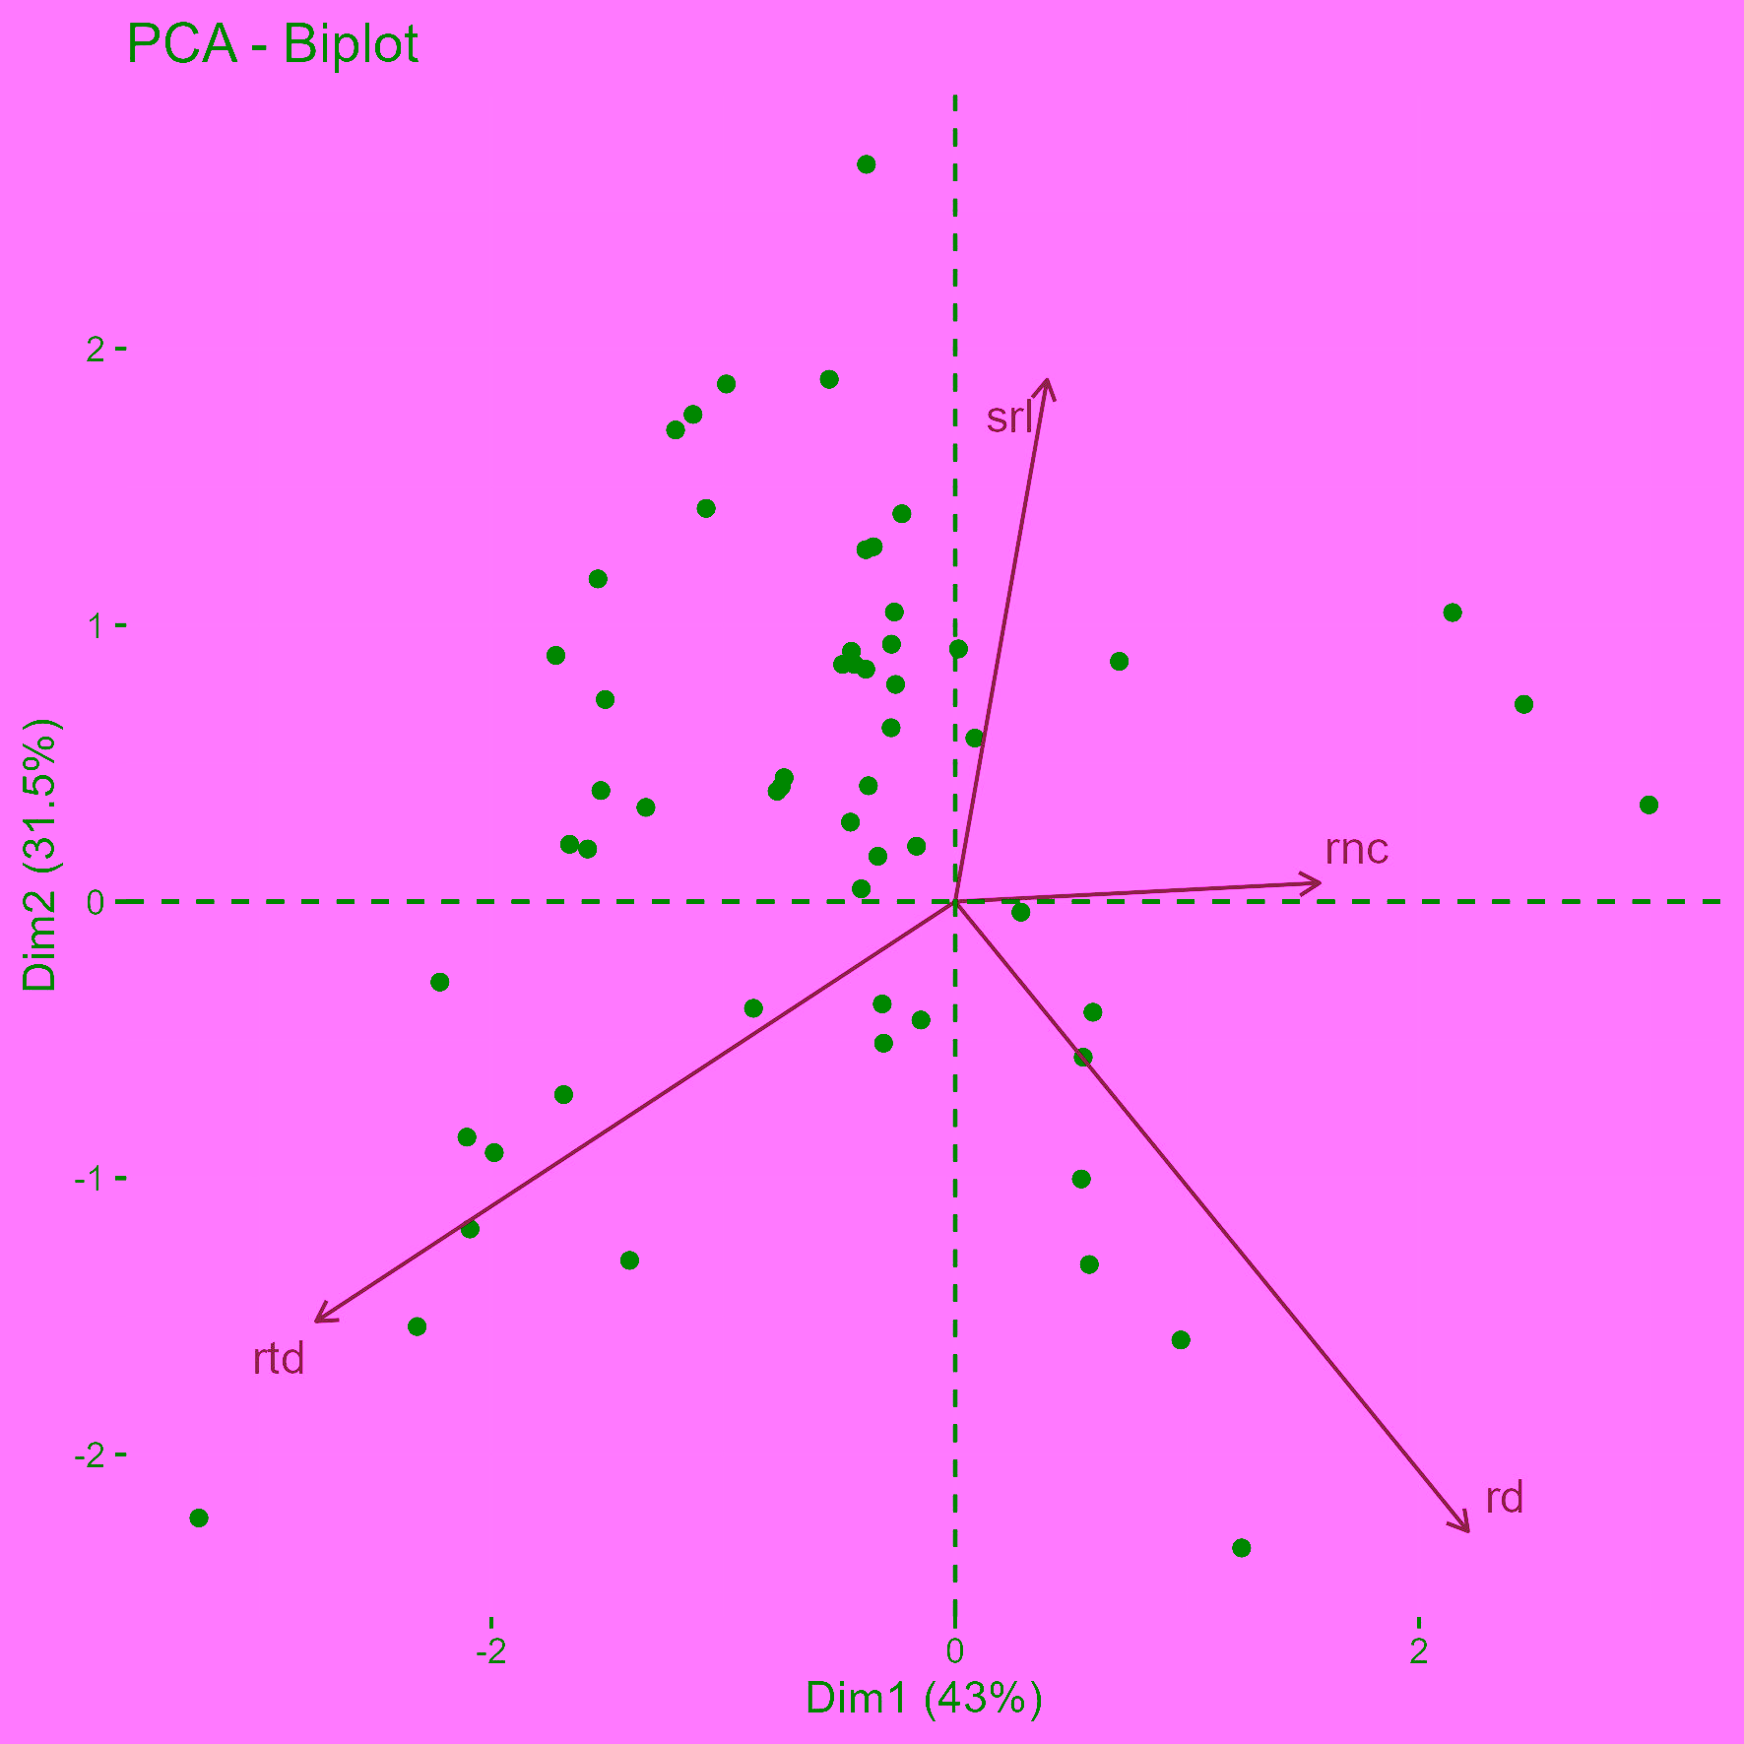
Fig. 21 Root traits PCA without woodiness. Includes both woody and non-woody genera.

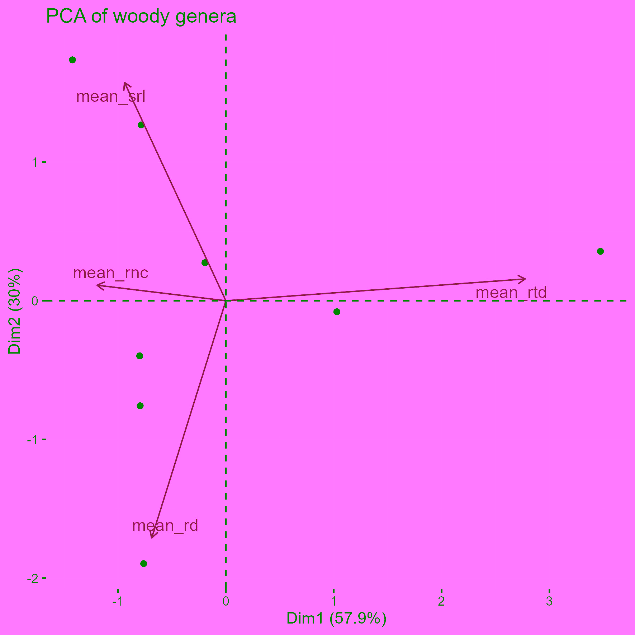
Fig. 22 PCA for woody genera root traits. Note that only genera where all 4 traits are present are used.

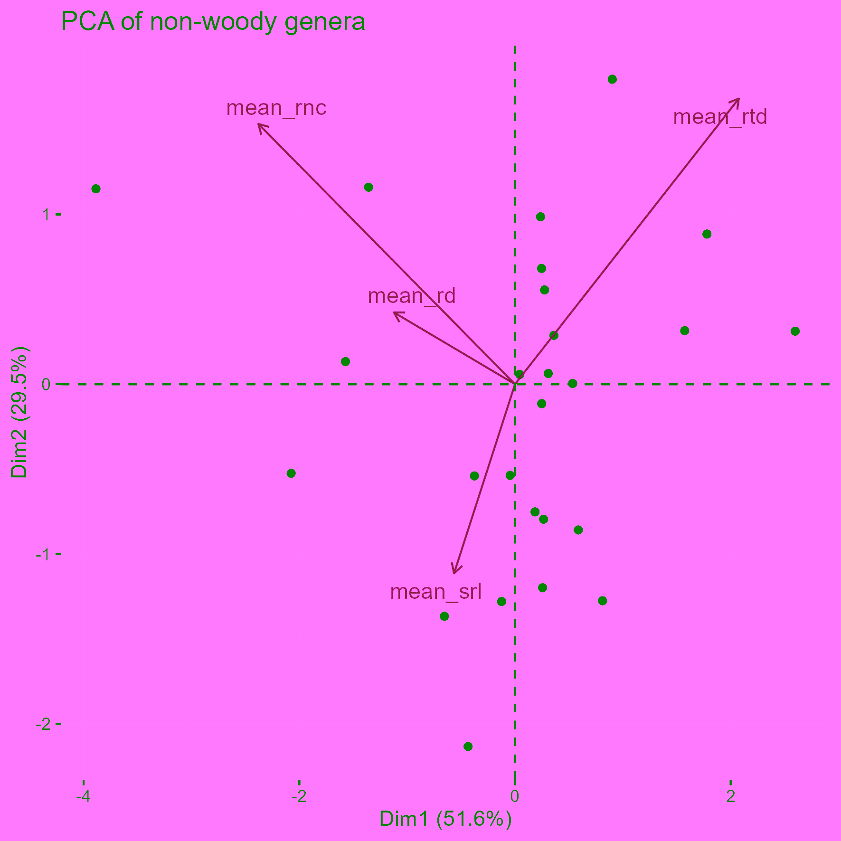
Fig. 23 PCA for non-woody genera root traits. Here, the rd-srl opposition seems less pronounced, but still there.

